**Data Structures and Algorithms**

[**Bit Magic**](https://practice.geeksforgeeks.org/tracks/DSASP-Mathematics/?batchId=154)

Bitwise Operators in CPP (Part 1)

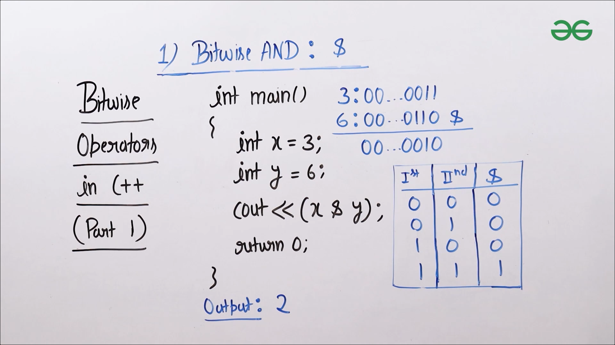

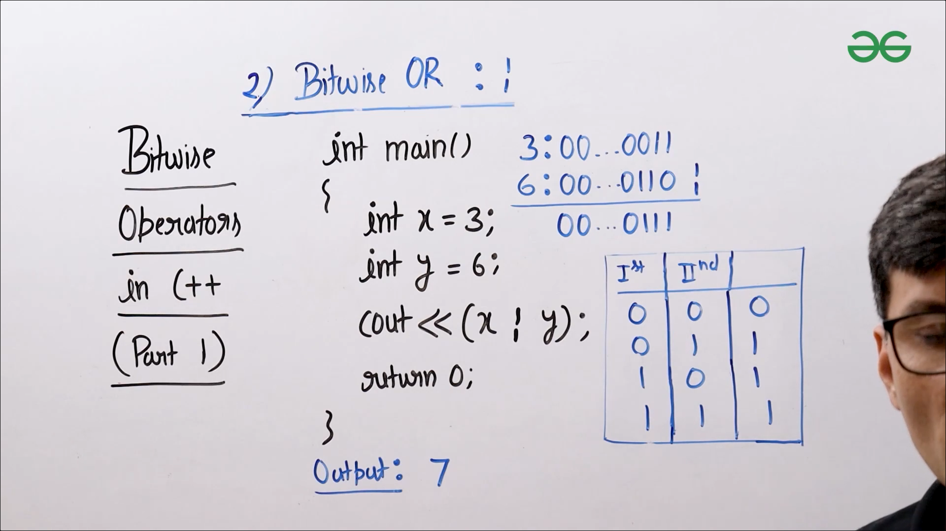

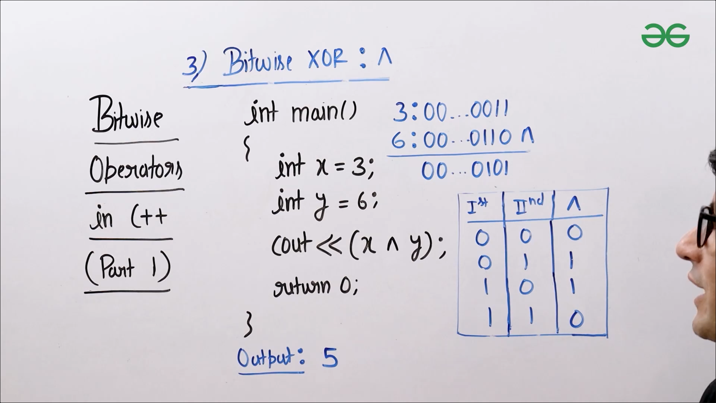

* CPP: <https://ide.geeksforgeeks.org/jWXP2t5Fne>
* JAVA: <https://ide.geeksforgeeks.org/c75fd291-956b-4d17-b1d1-9d51189d094c>

Bitwise Operators in CPP (Part 2)

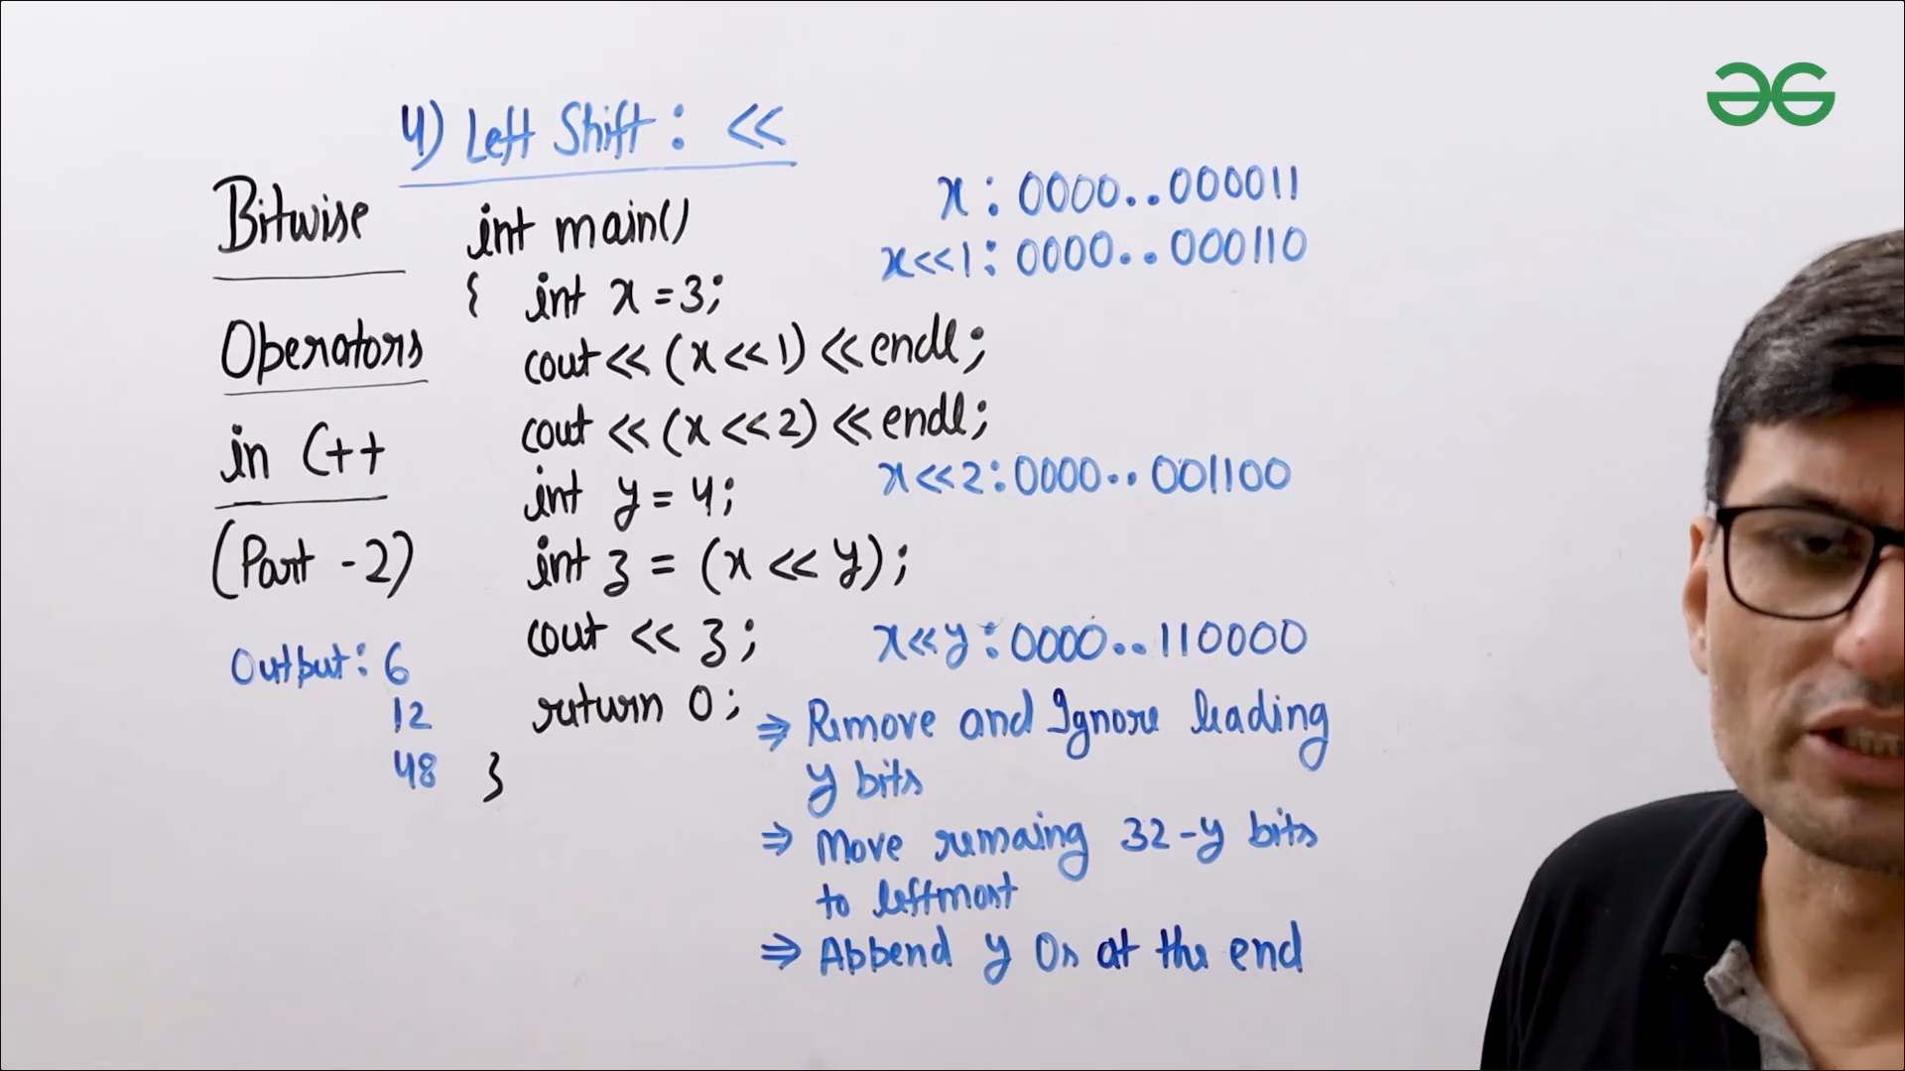

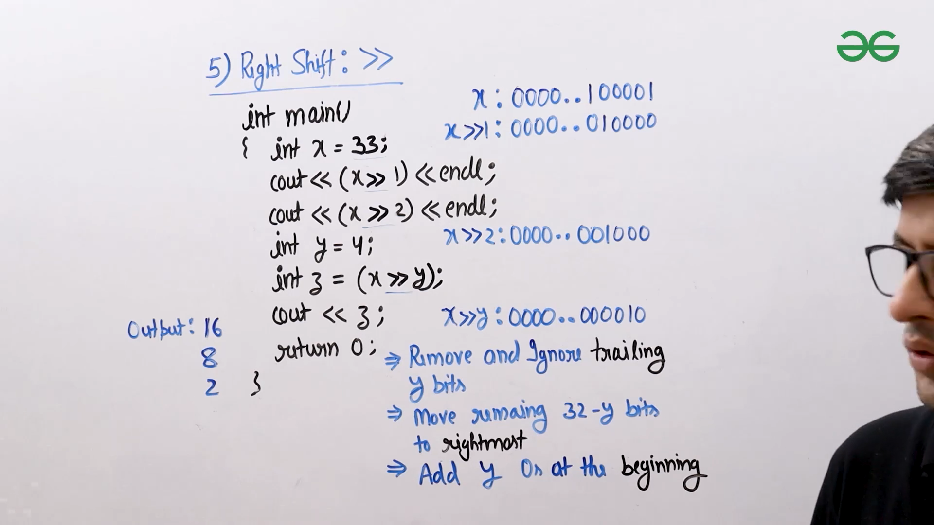

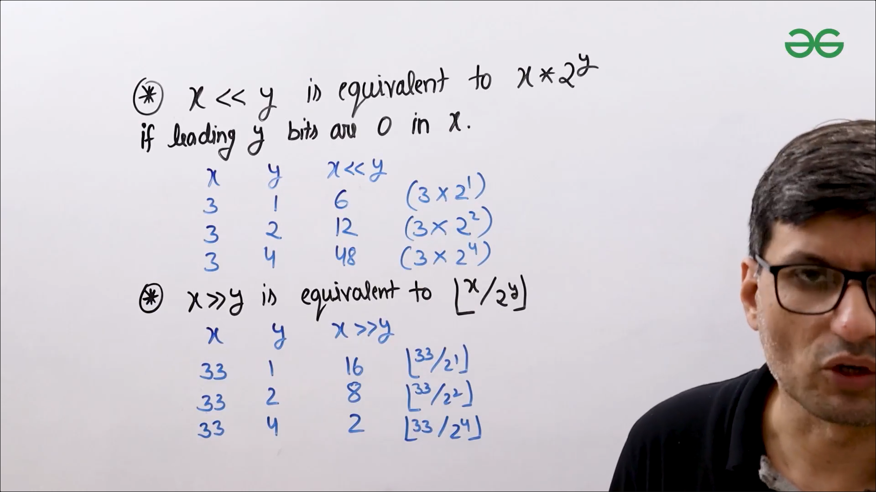

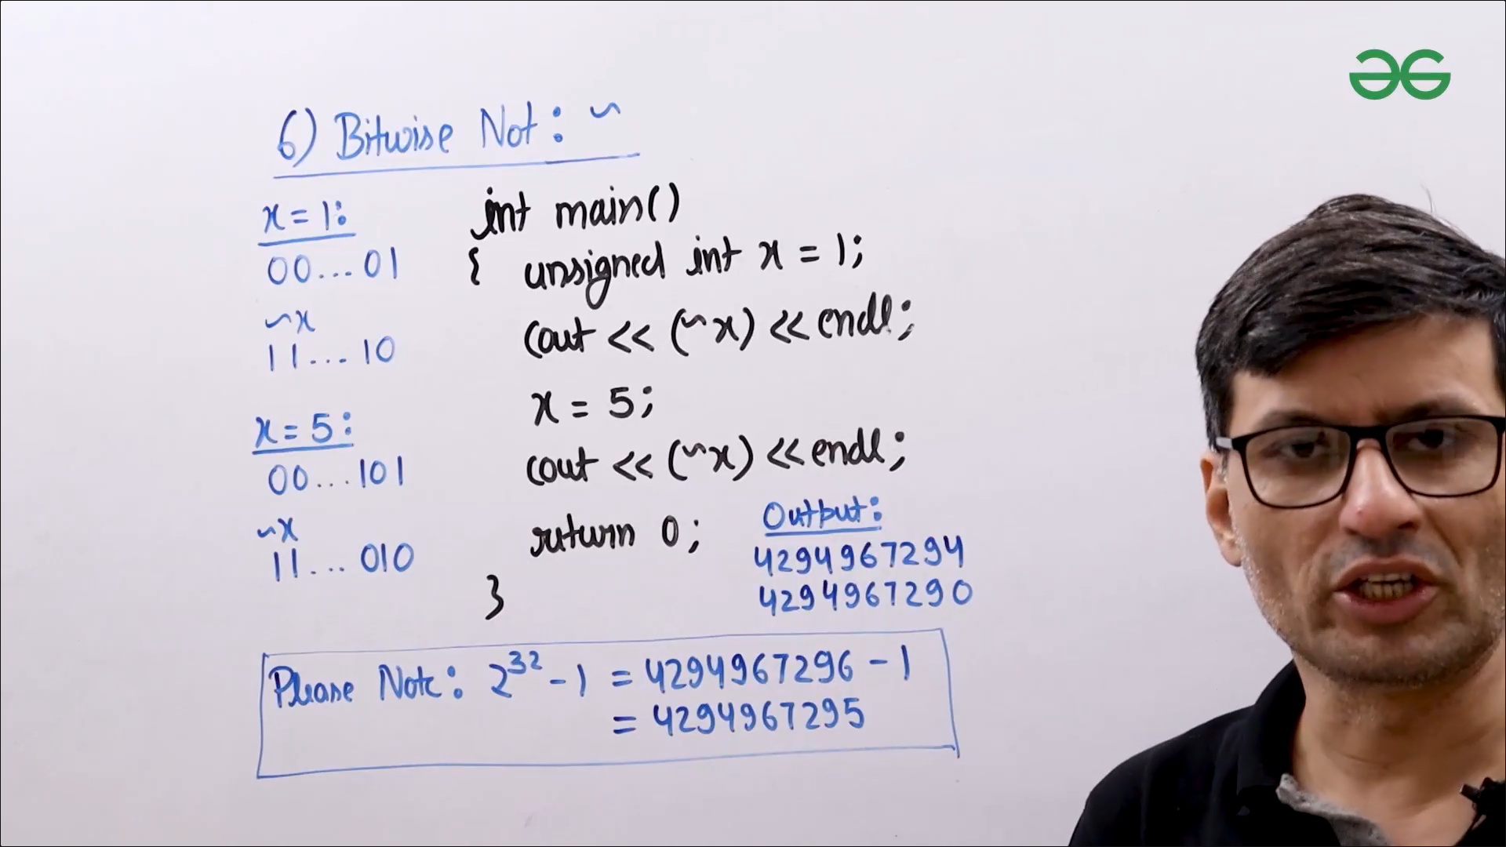

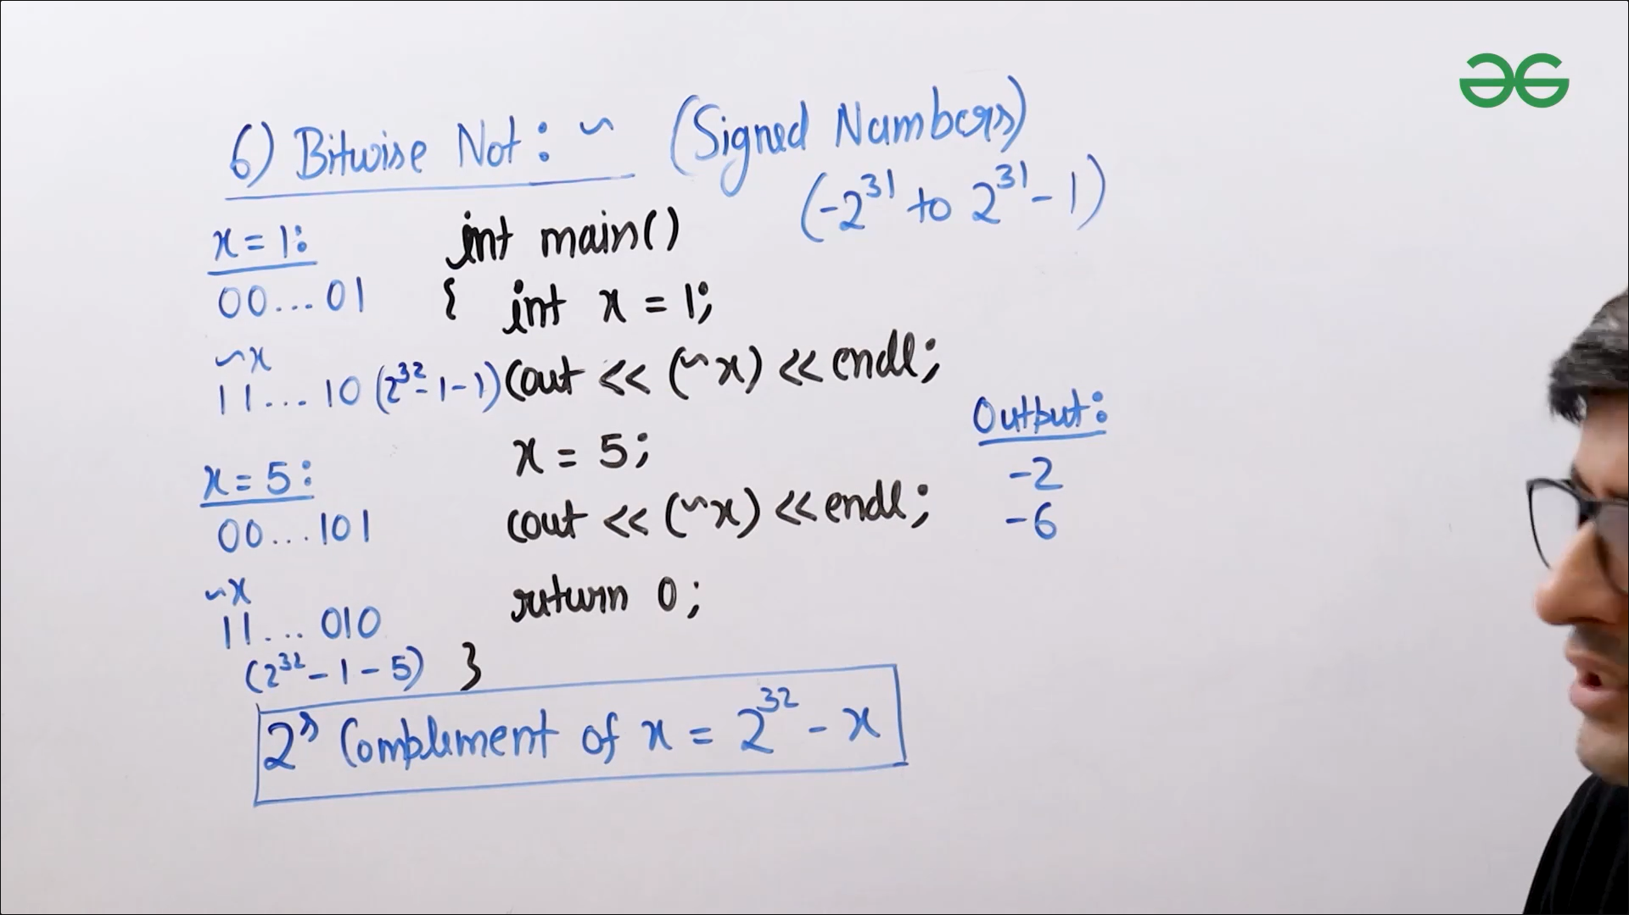

* Example
  + JAVA: <https://ide.geeksforgeeks.org/aKIuHW2K4S>
* Example(Bitwise Not, Signed Input)
  + CPP: <https://ide.geeksforgeeks.org/JLMWvyqycY>
* Example(Bitwise Not, Unsigned Input)
  + CPP: <https://ide.geeksforgeeks.org/xBPlSrZAX3>
* Example(Right Shift)
  + CPP: <https://ide.geeksforgeeks.org/AtRdo4dtah>
* Example(Left Shift)
  + CPP: <https://ide.geeksforgeeks.org/HPpSTBxyFv>

Bitwise Operators in Java (Part 1)

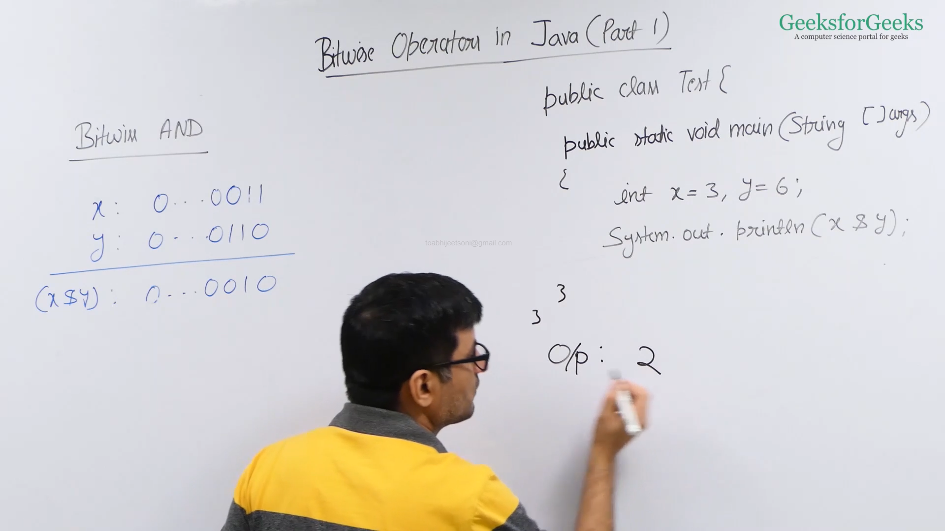

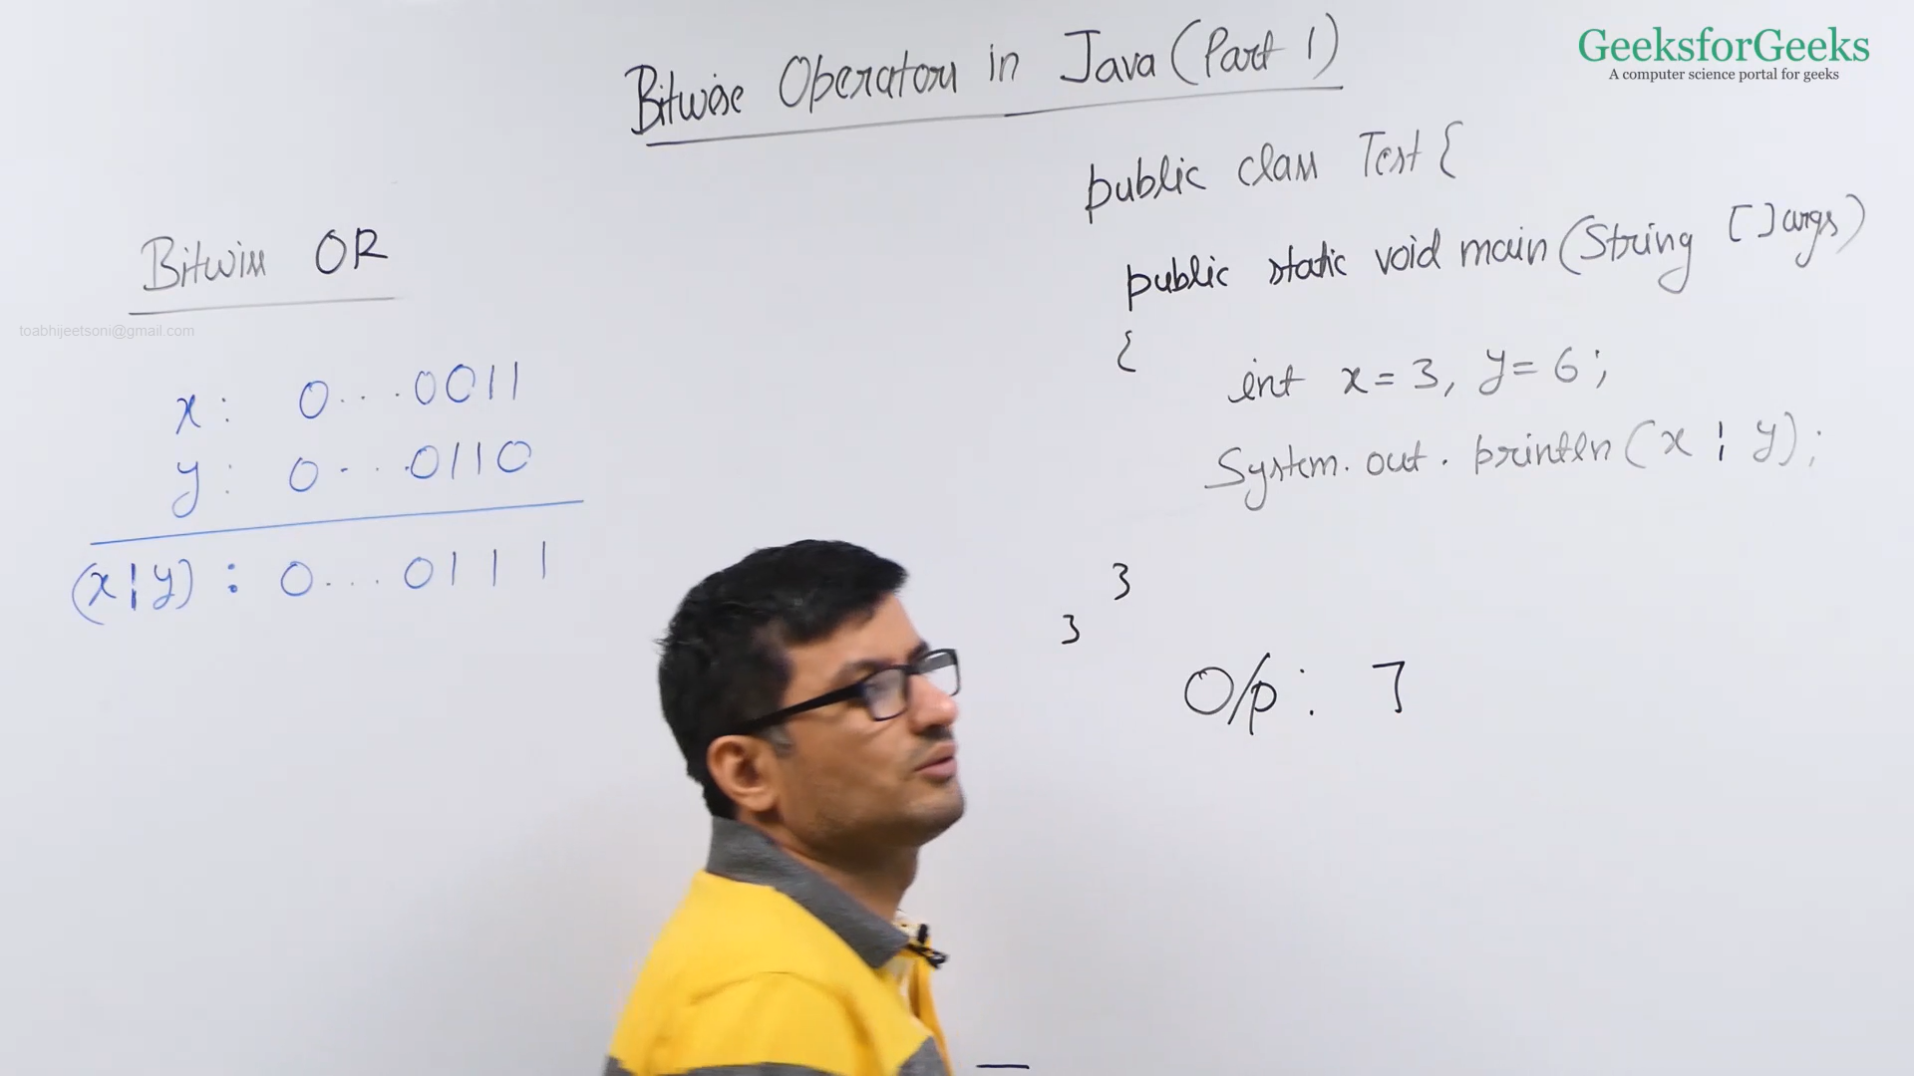

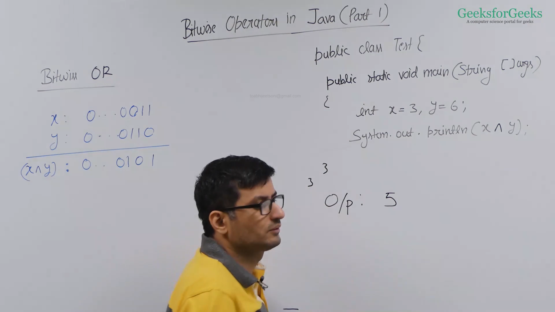

* Example(Bitwise Xor)
  + Java: <https://ide.geeksforgeeks.org/OXeG0NqJdV>
* Example(Bitwise Or)
  + Java: <https://ide.geeksforgeeks.org/7oQbqefnEj>
* Example(Bitwise And)
  + Java: <https://ide.geeksforgeeks.org/JjFLRKup5E>

Bitwise Operators in Java (Part 2)

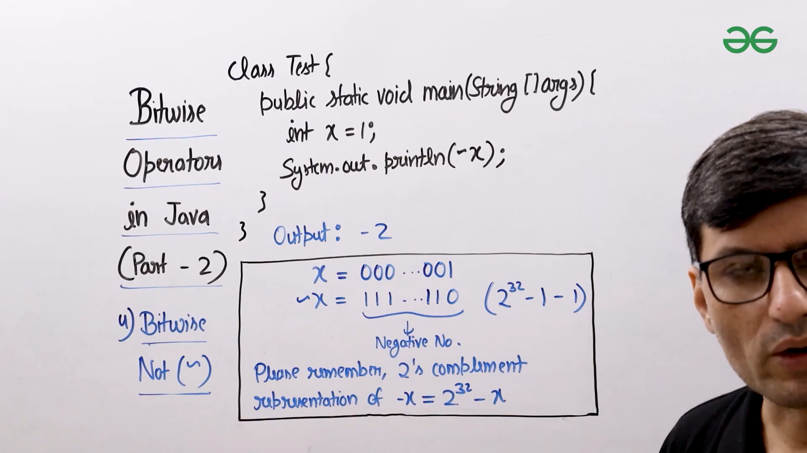

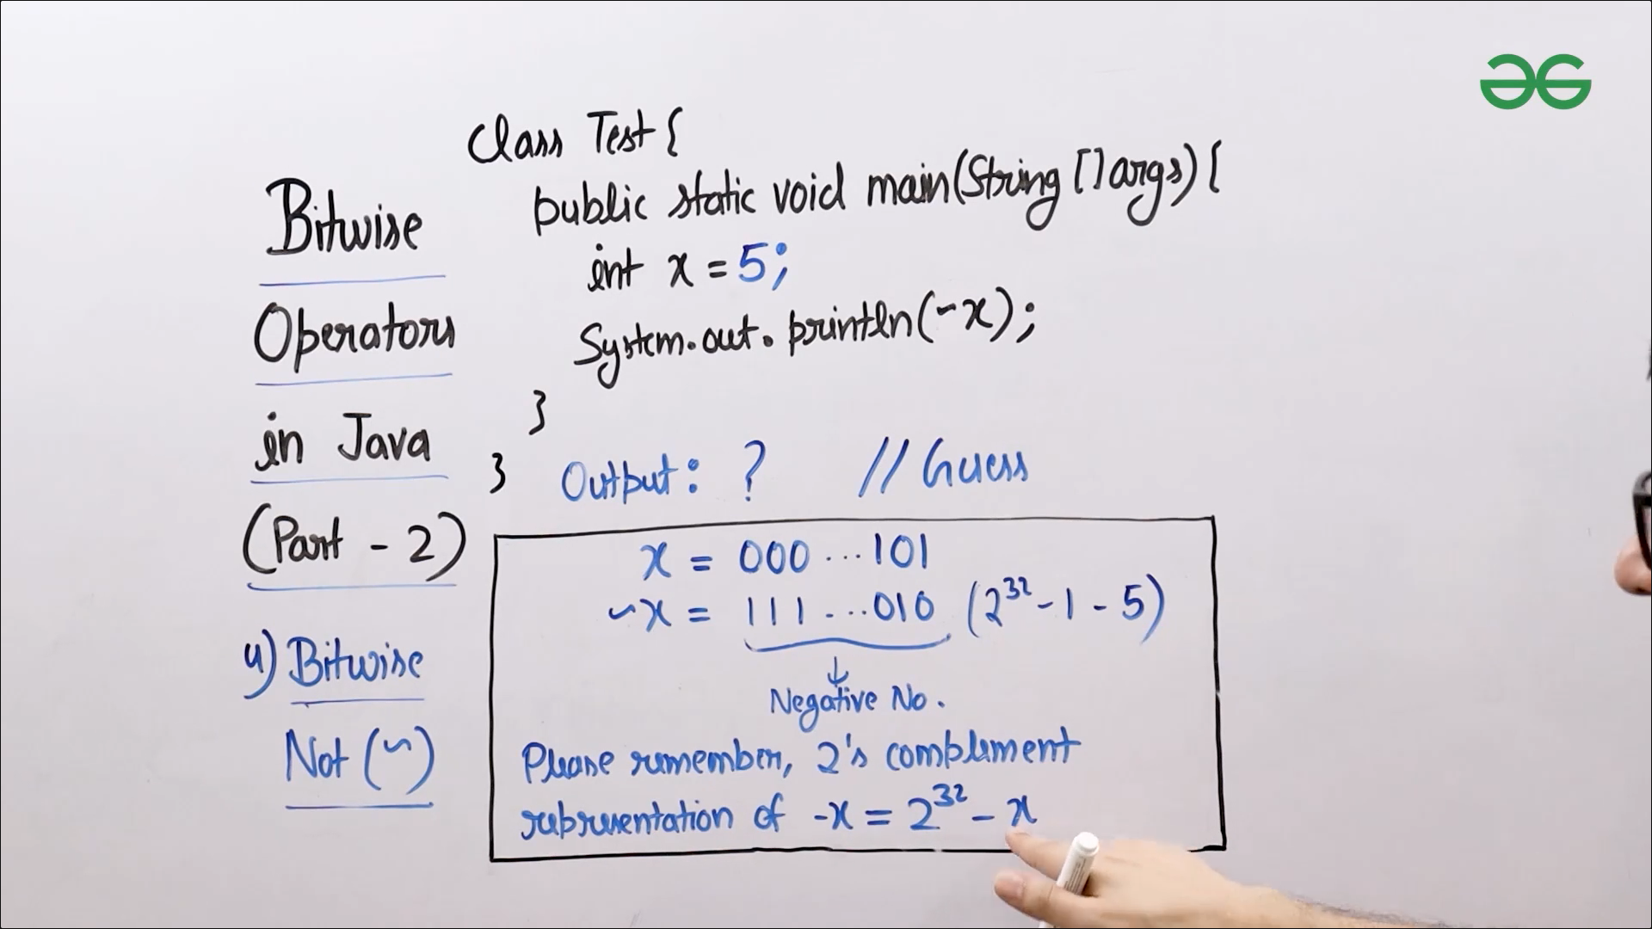

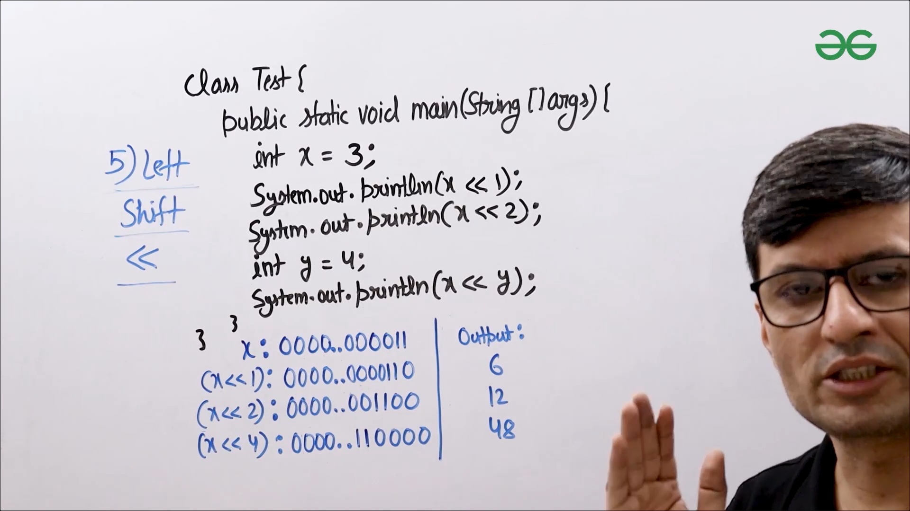

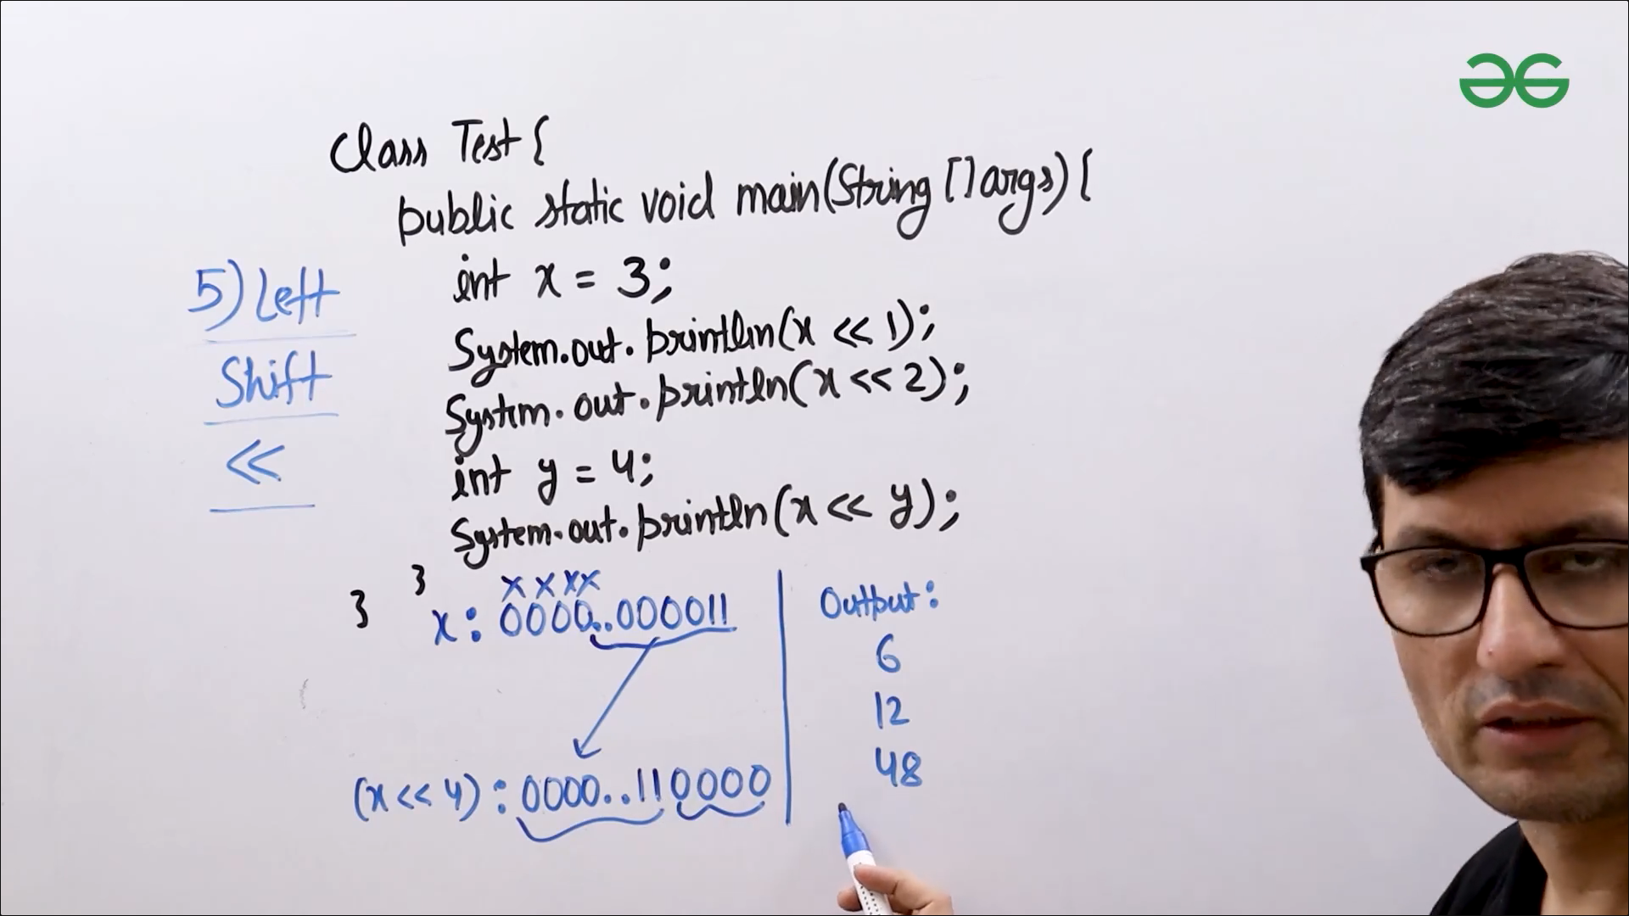

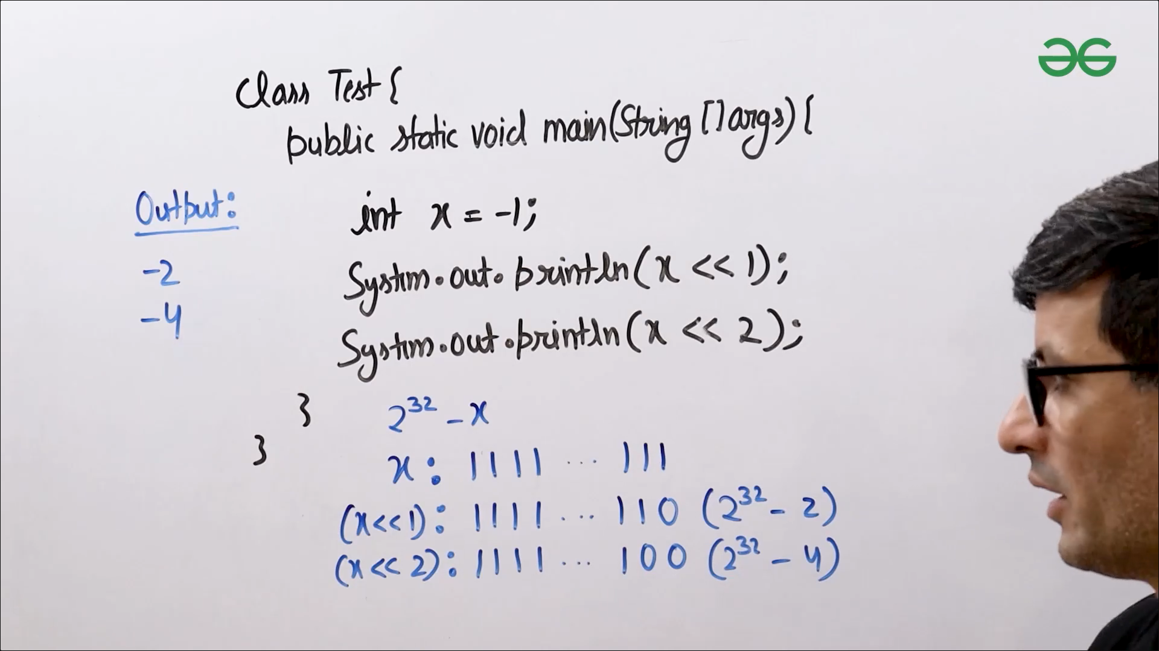

* Example(Left Shift with Negative Number)
  + Java: <https://ide.geeksforgeeks.org/HGqOzeXZzf>
* Example(Left Shift)
  + Java: <https://ide.geeksforgeeks.org/Fkfvhnpfdh>
* Example(Bitwise Not)
  + Java: <https://ide.geeksforgeeks.org/gQdo4m1K54>

Bitwise Operators in Java (Part 3)

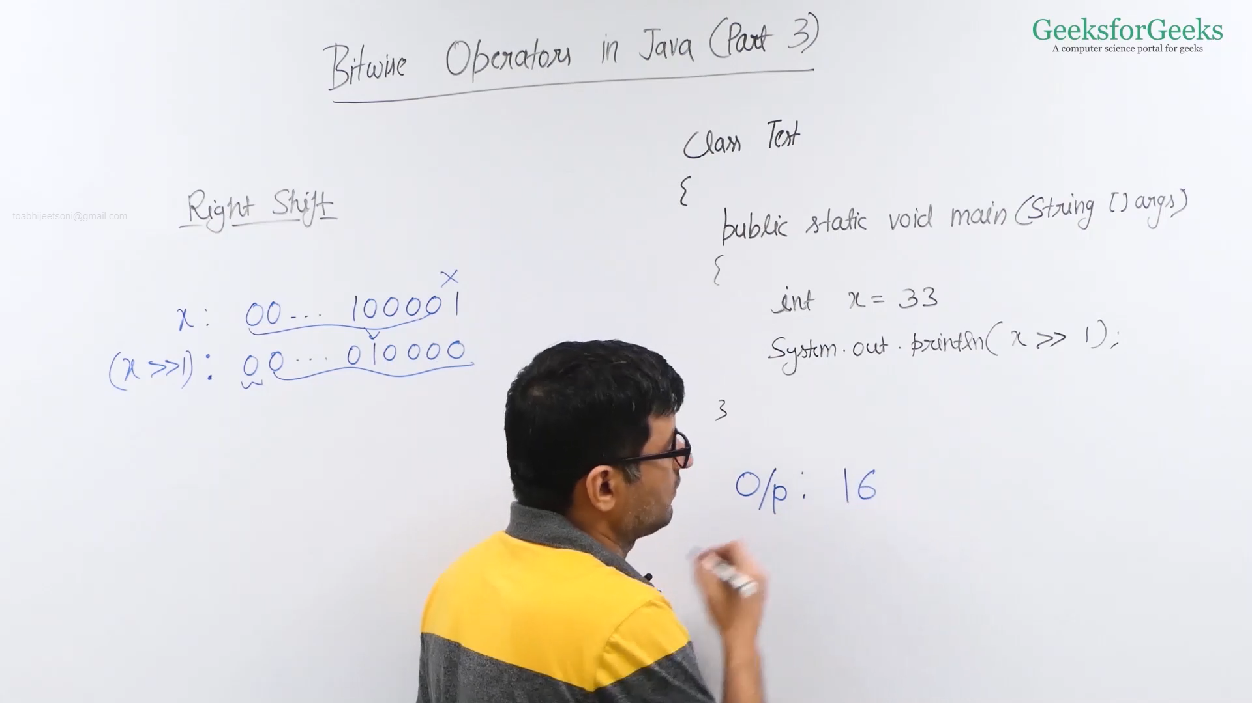

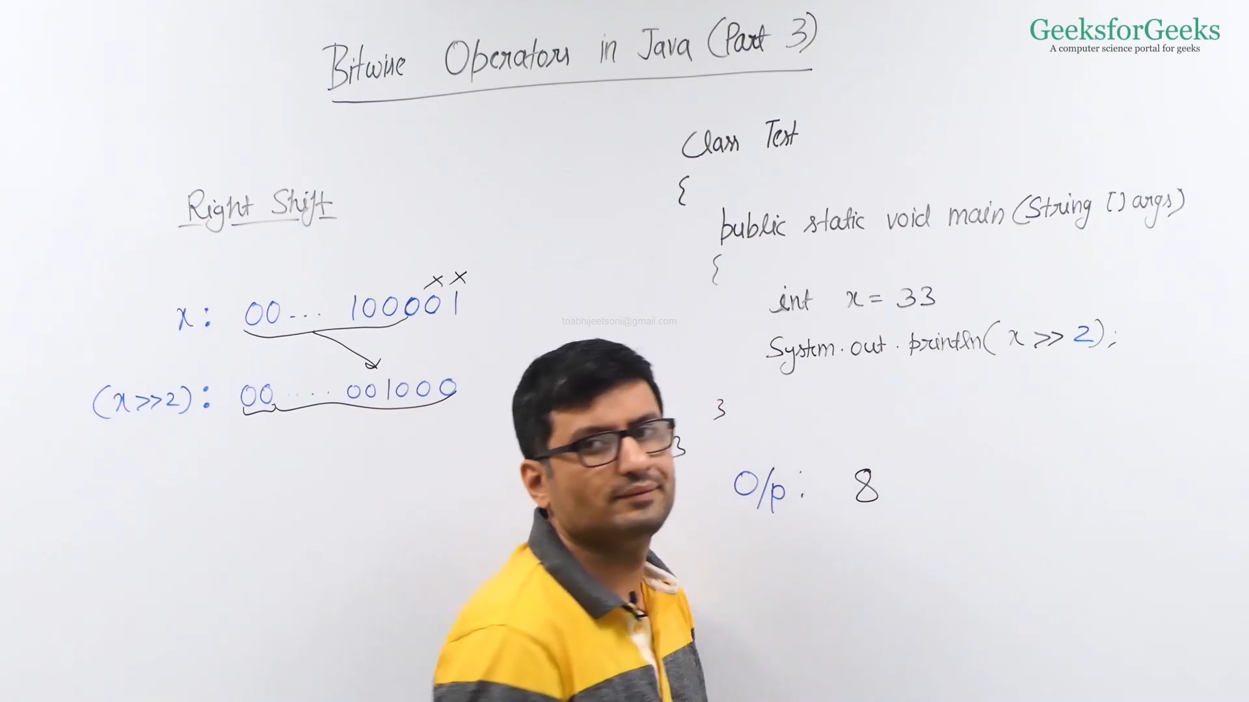

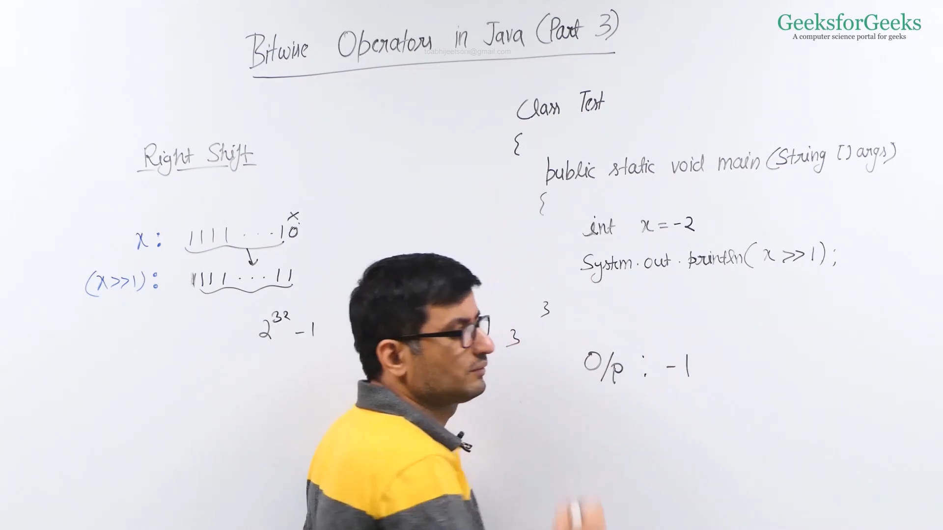

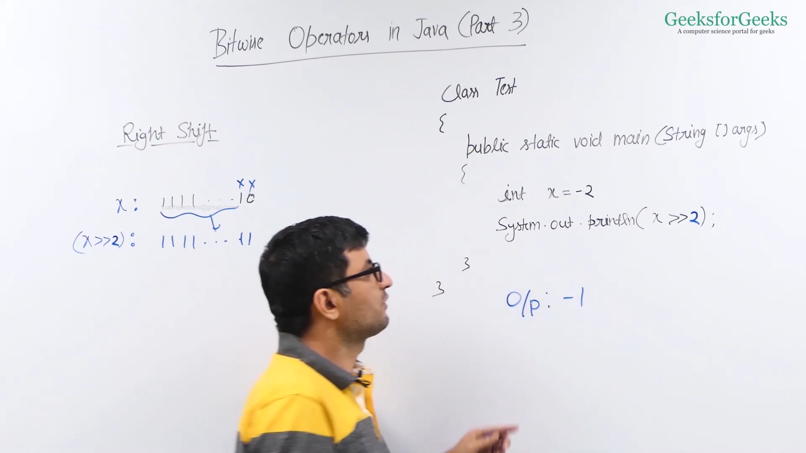

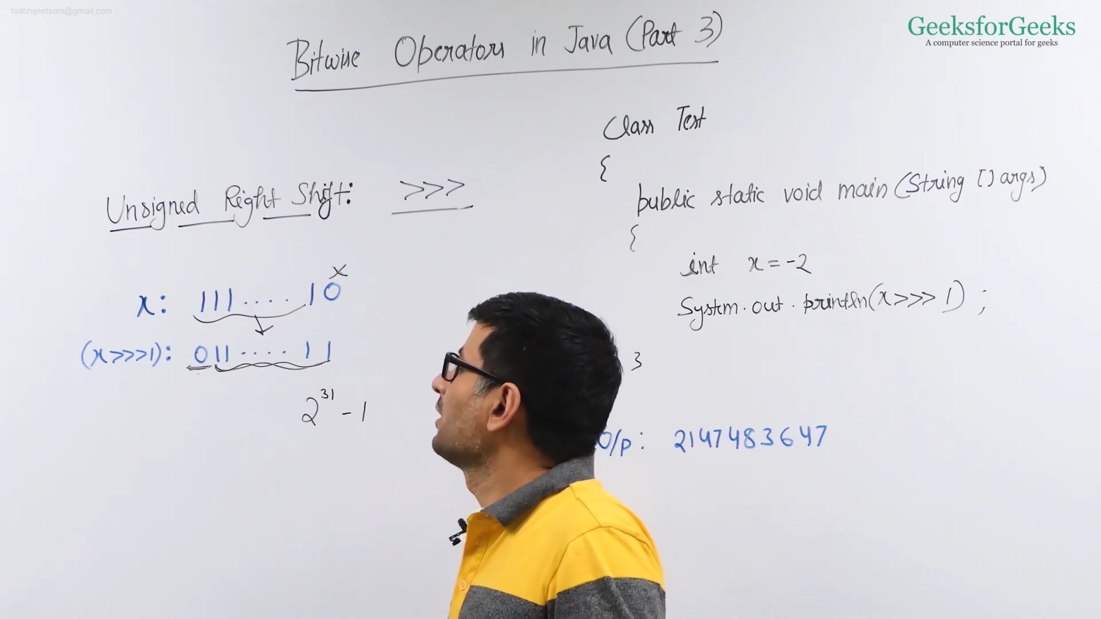

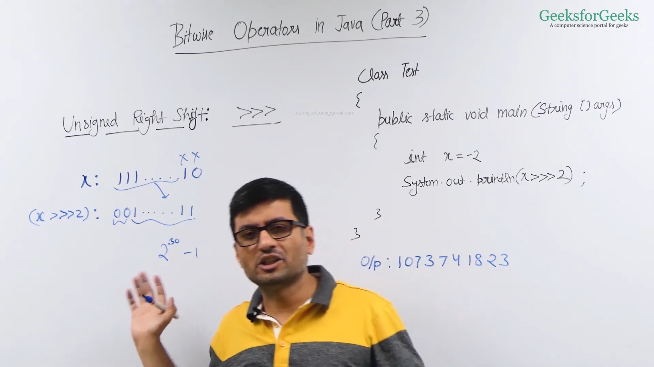

* Example(Unsigned Right Shift)
  + Java: <https://ide.geeksforgeeks.org/xvIaHzuK39>
* Example(Right Shift with Negative Number)
  + Java: <https://ide.geeksforgeeks.org/dia9qM3Onz>
* Example(Right Shift)
  + Java: <https://ide.geeksforgeeks.org/k0KH7F3zVH>
* Example(Right Shift)
  + Java: <https://ide.geeksforgeeks.org/IXfuQDXYcI>

Check Kth bit is set or not

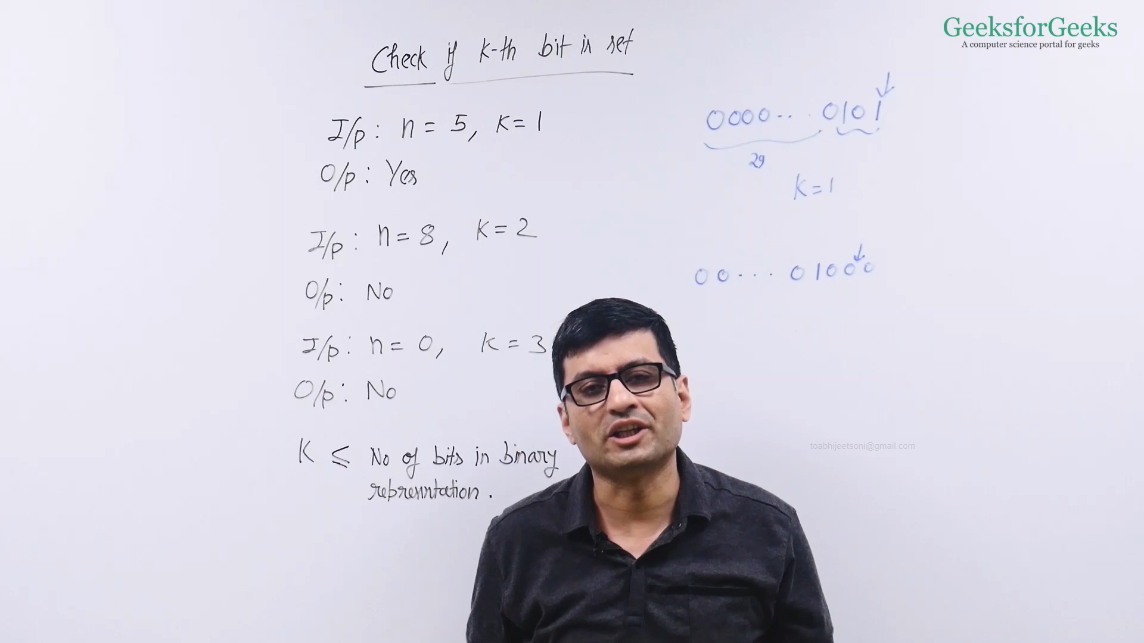

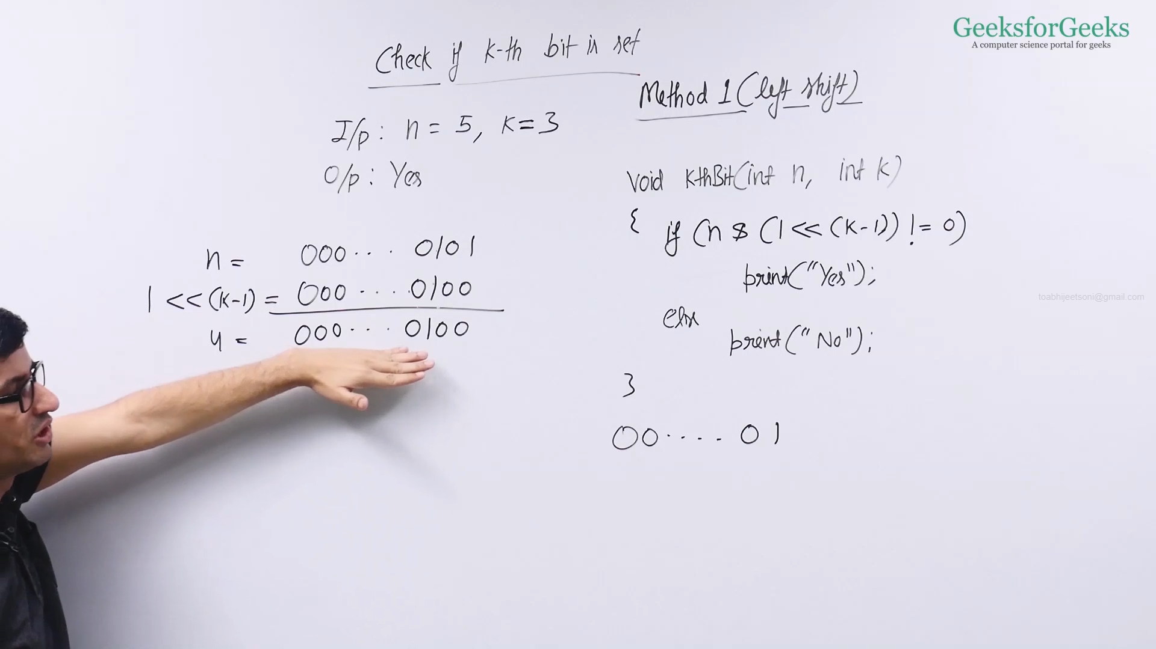

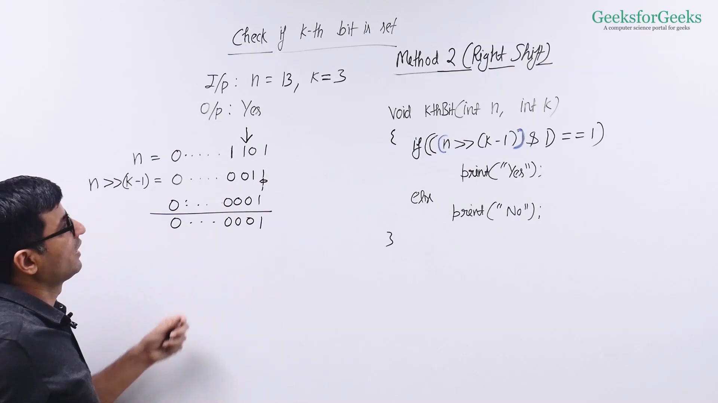

* **Method 1 (Using Left Shift)**
  + C++ : <https://ide.geeksforgeeks.org/6JnRs4TxBN>
  + Java : <https://ide.geeksforgeeks.org/hCQaaJ4lWF>
* **Method 2 (Using Right Shift)**
  + C++ **:**<https://ide.geeksforgeeks.org/DJACIszUAC>
  + Java : <https://ide.geeksforgeeks.org/1lCpDtztDO>

Count set bits

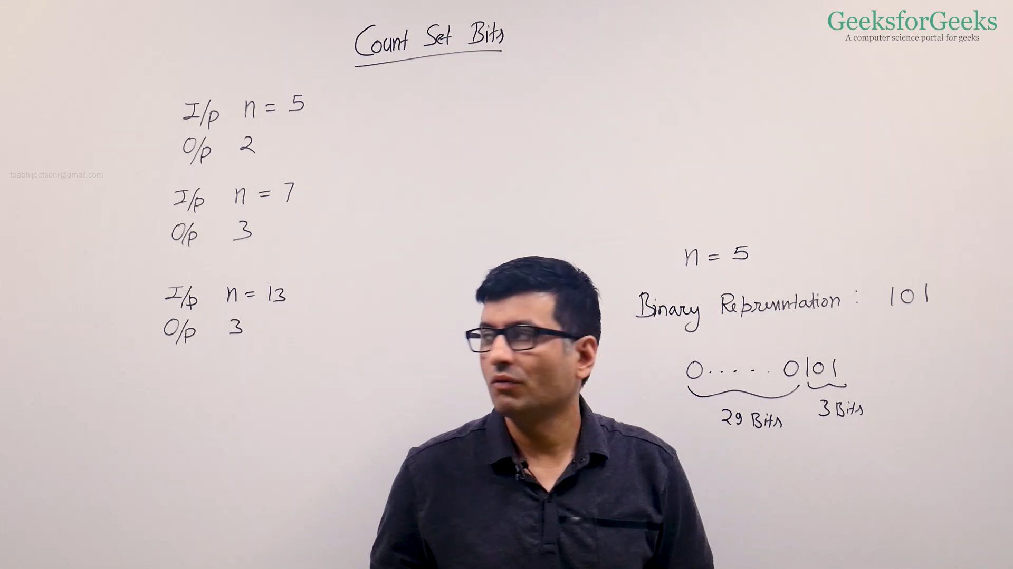

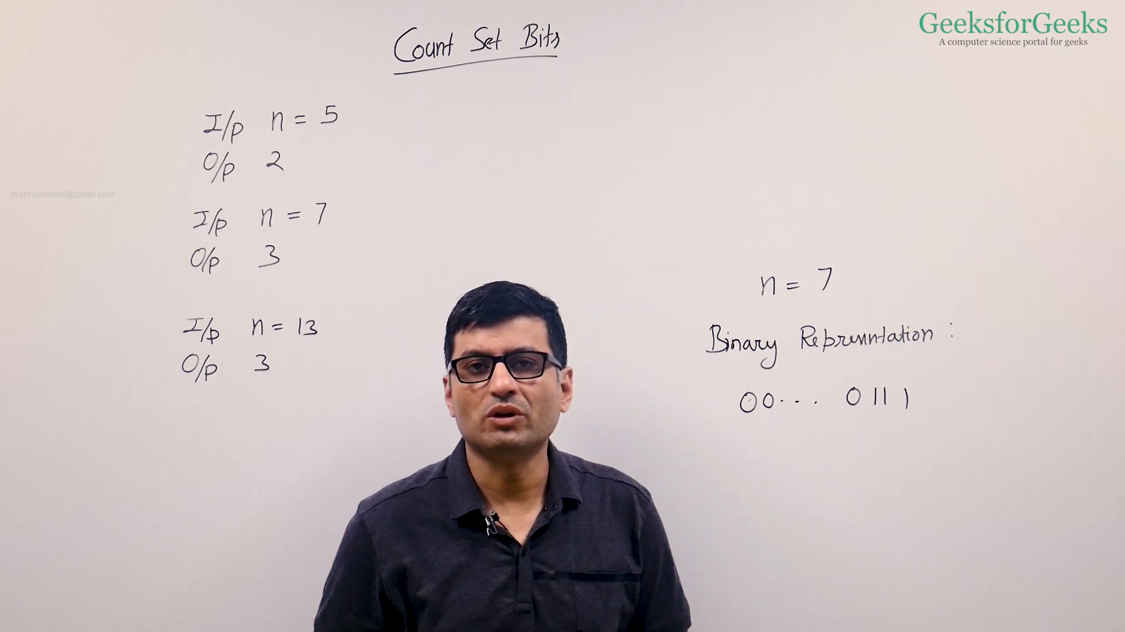

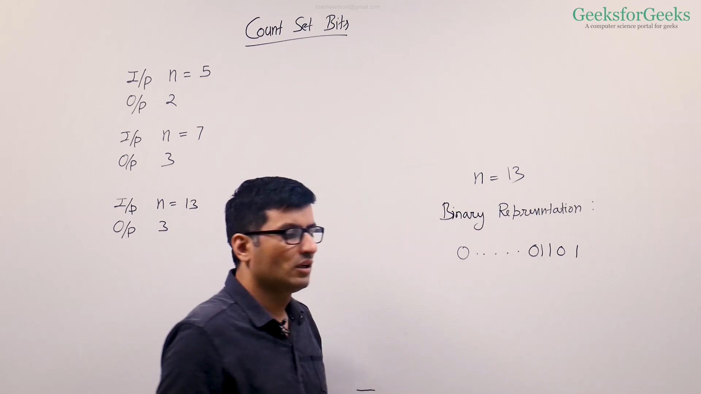

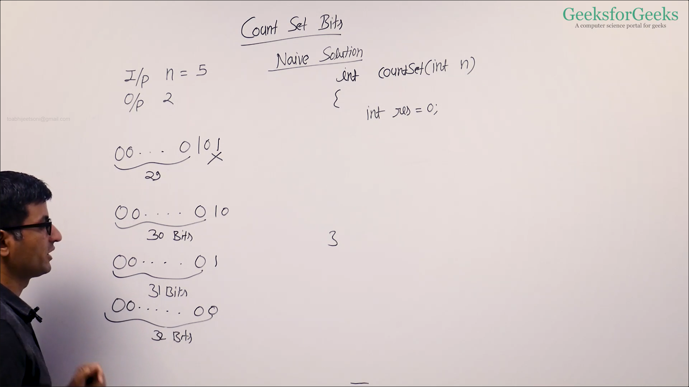

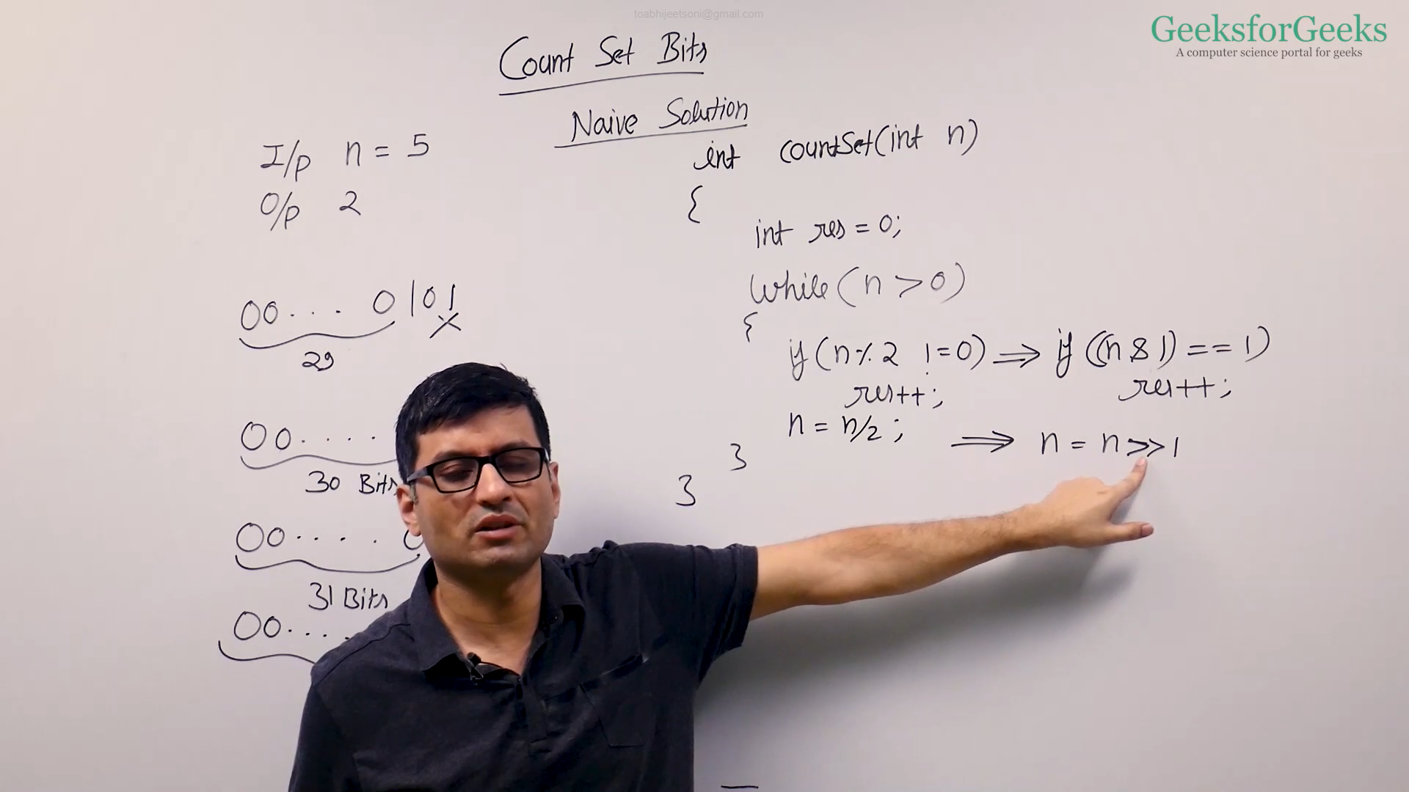

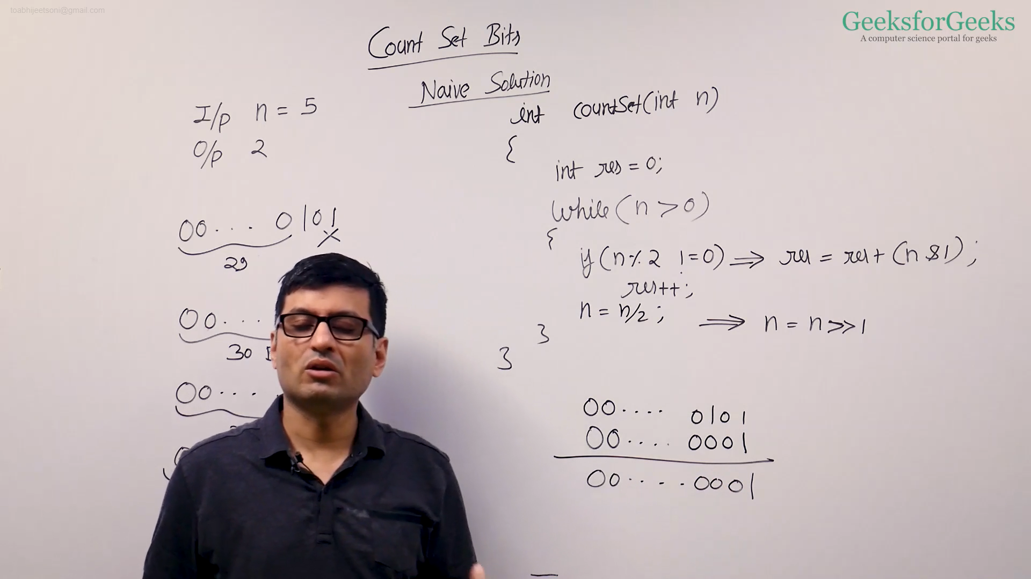

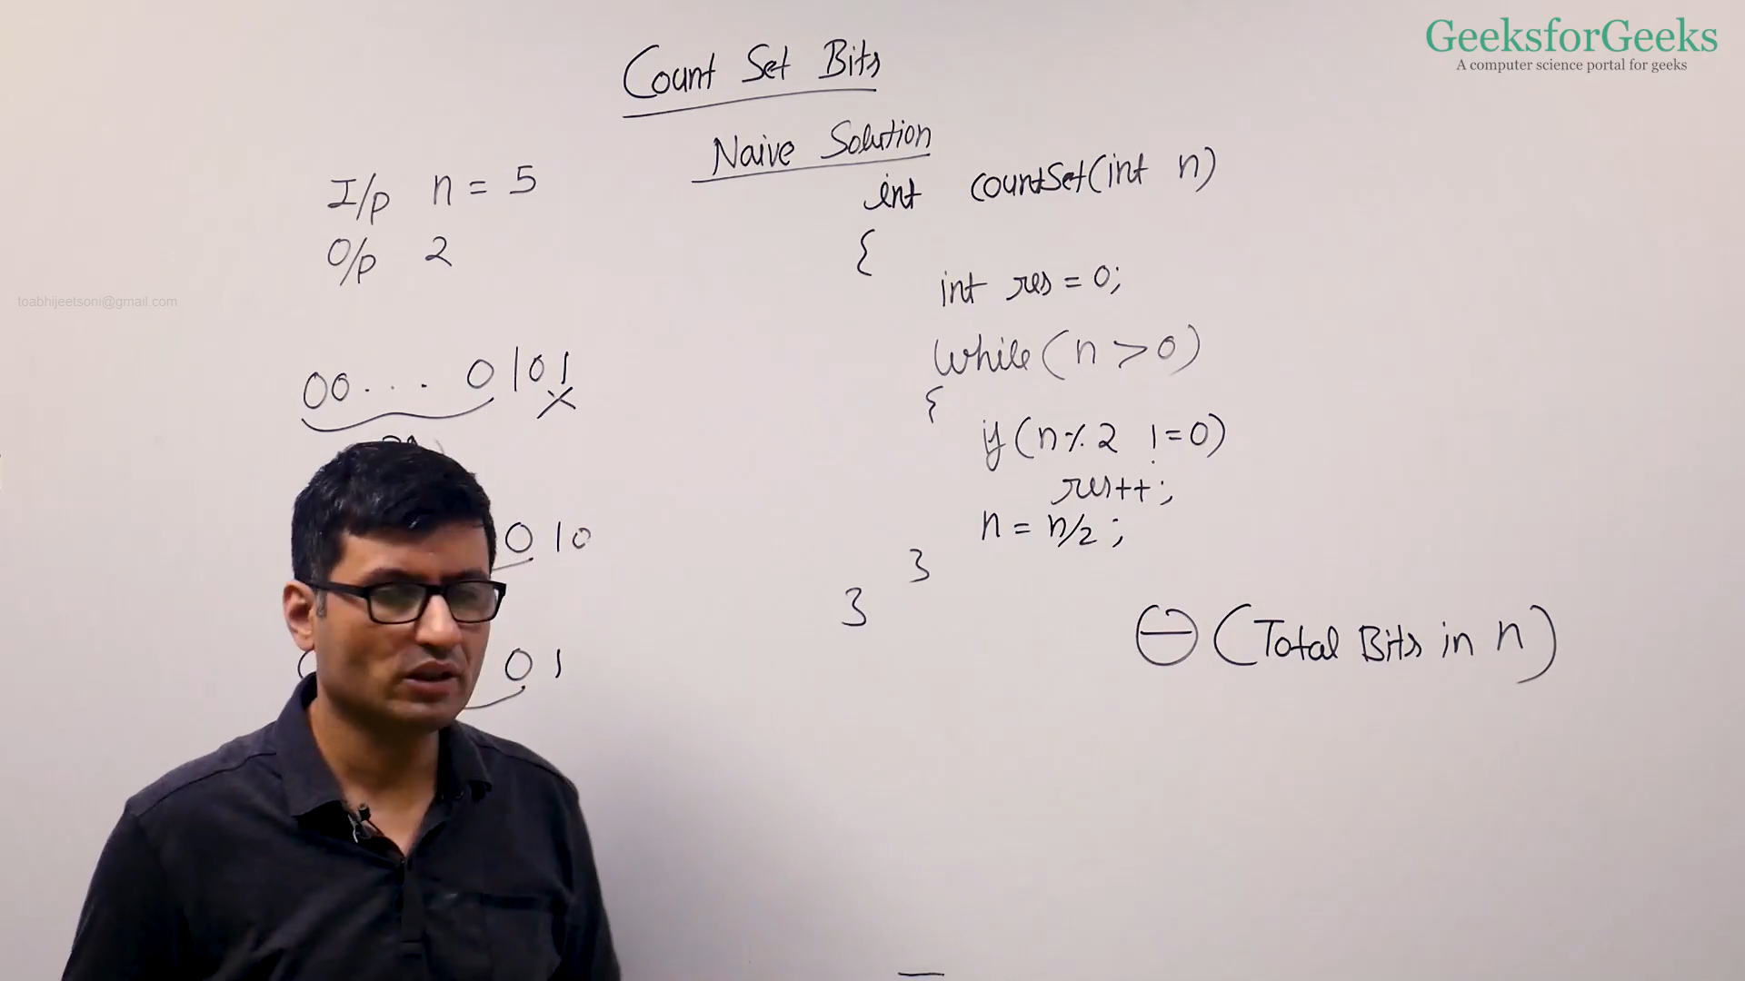

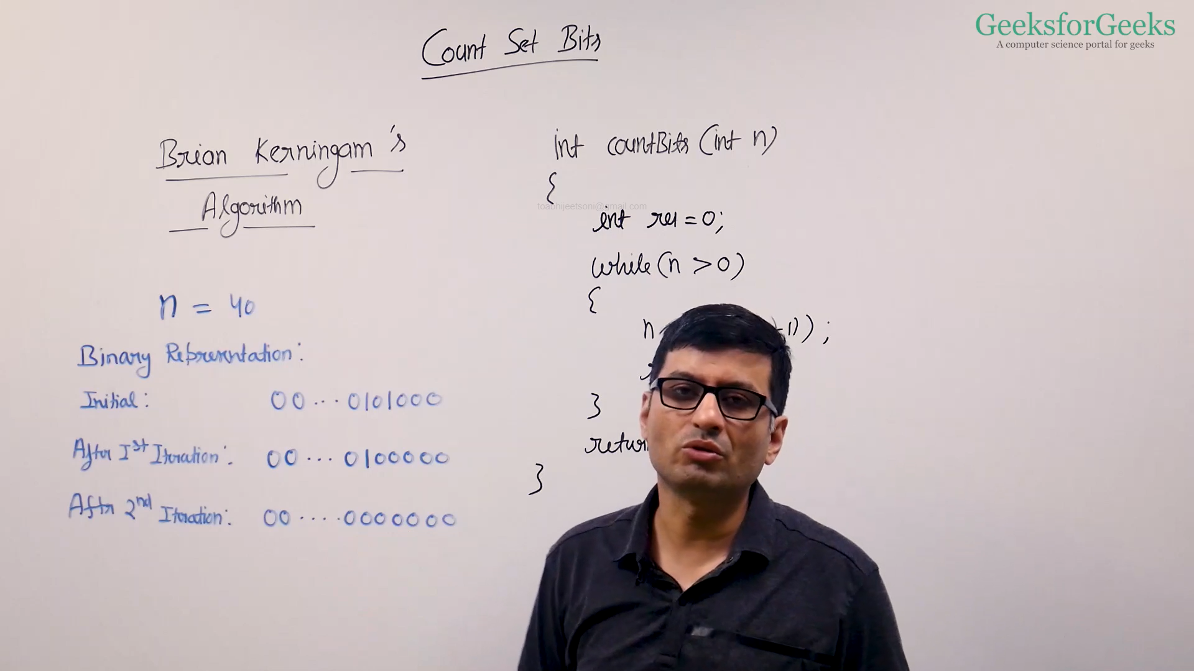

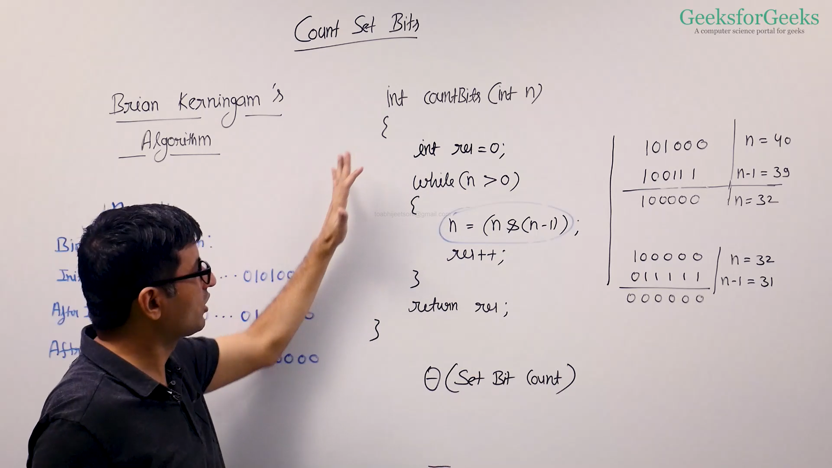

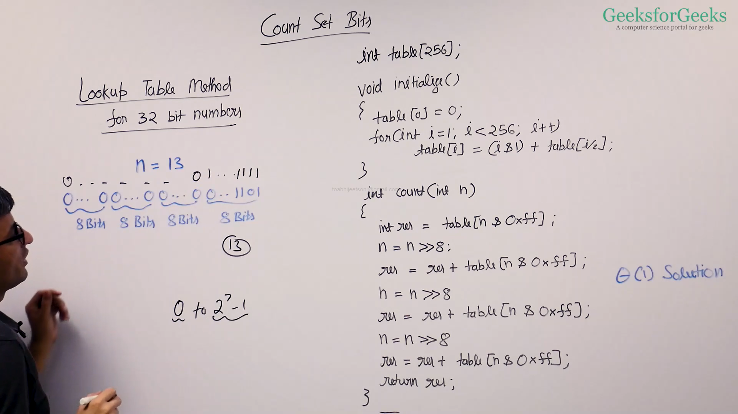

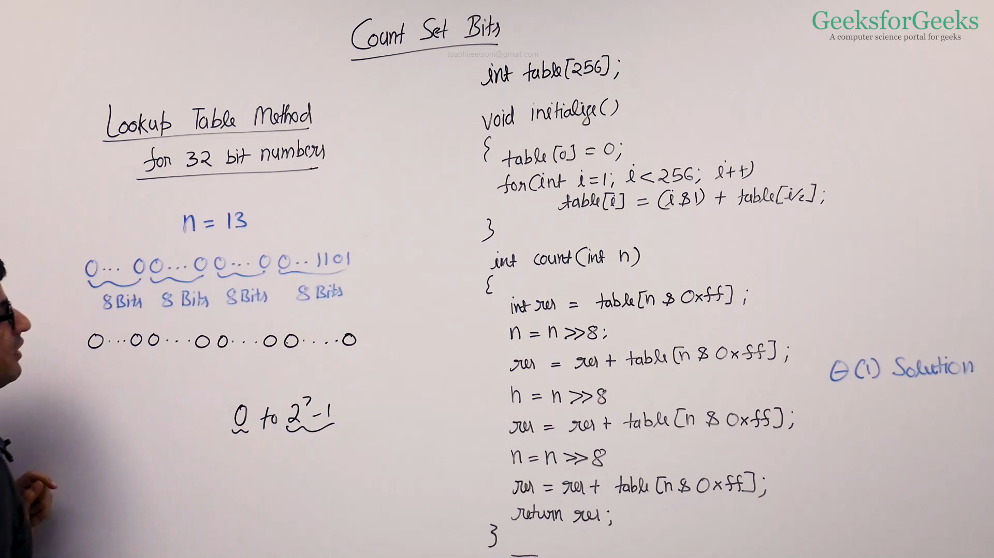

* **Method 1 (Simple)**
  + C++ : <https://ide.geeksforgeeks.org/7otYeSB2AG>
  + Java : <https://ide.geeksforgeeks.org/m6UmOWJKe3>
* **Method 2 (Brian and Kerningham Algorithm)**
  + C++ : <https://ide.geeksforgeeks.org/nc21zgWF1L>
  + Java : <https://ide.geeksforgeeks.org/qNX2GoDzIG>
* **Method 3 (Lookup Table)**
  + C++ : <https://ide.geeksforgeeks.org/fdmJUCXVNl>
  + Java : <https://ide.geeksforgeeks.org/0fOYHmm55D>

Power of Two

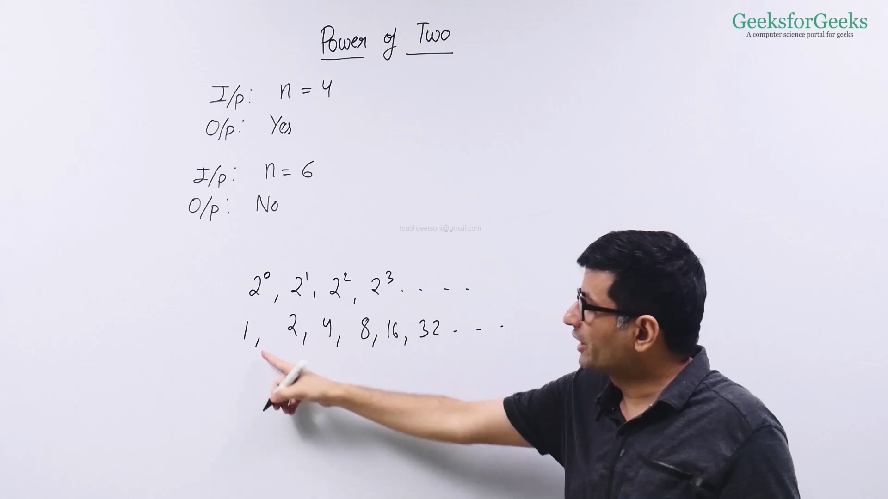

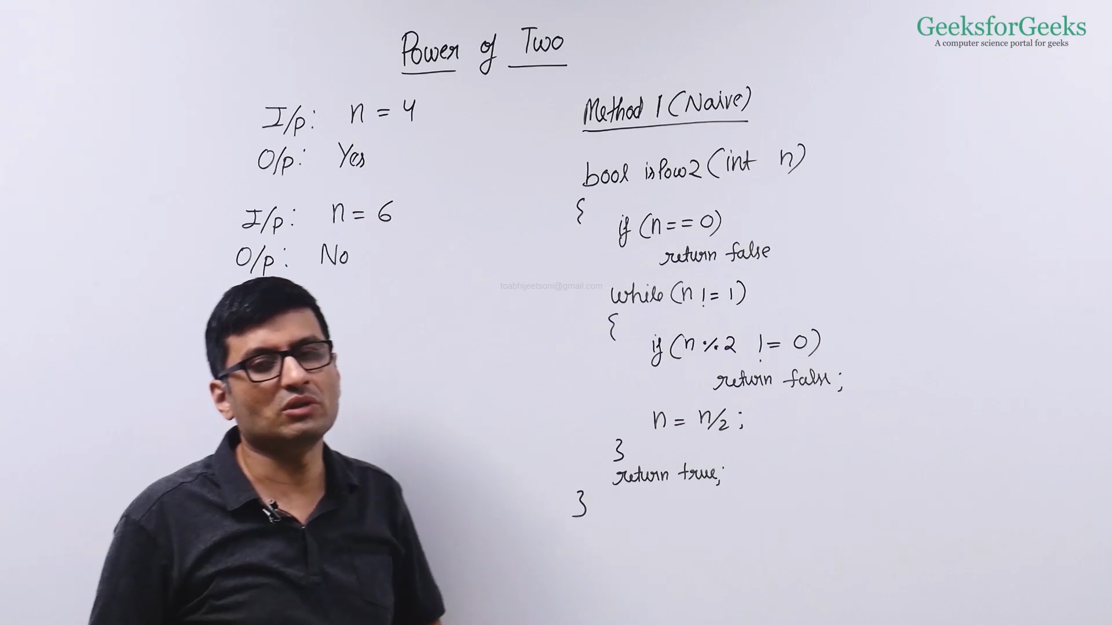

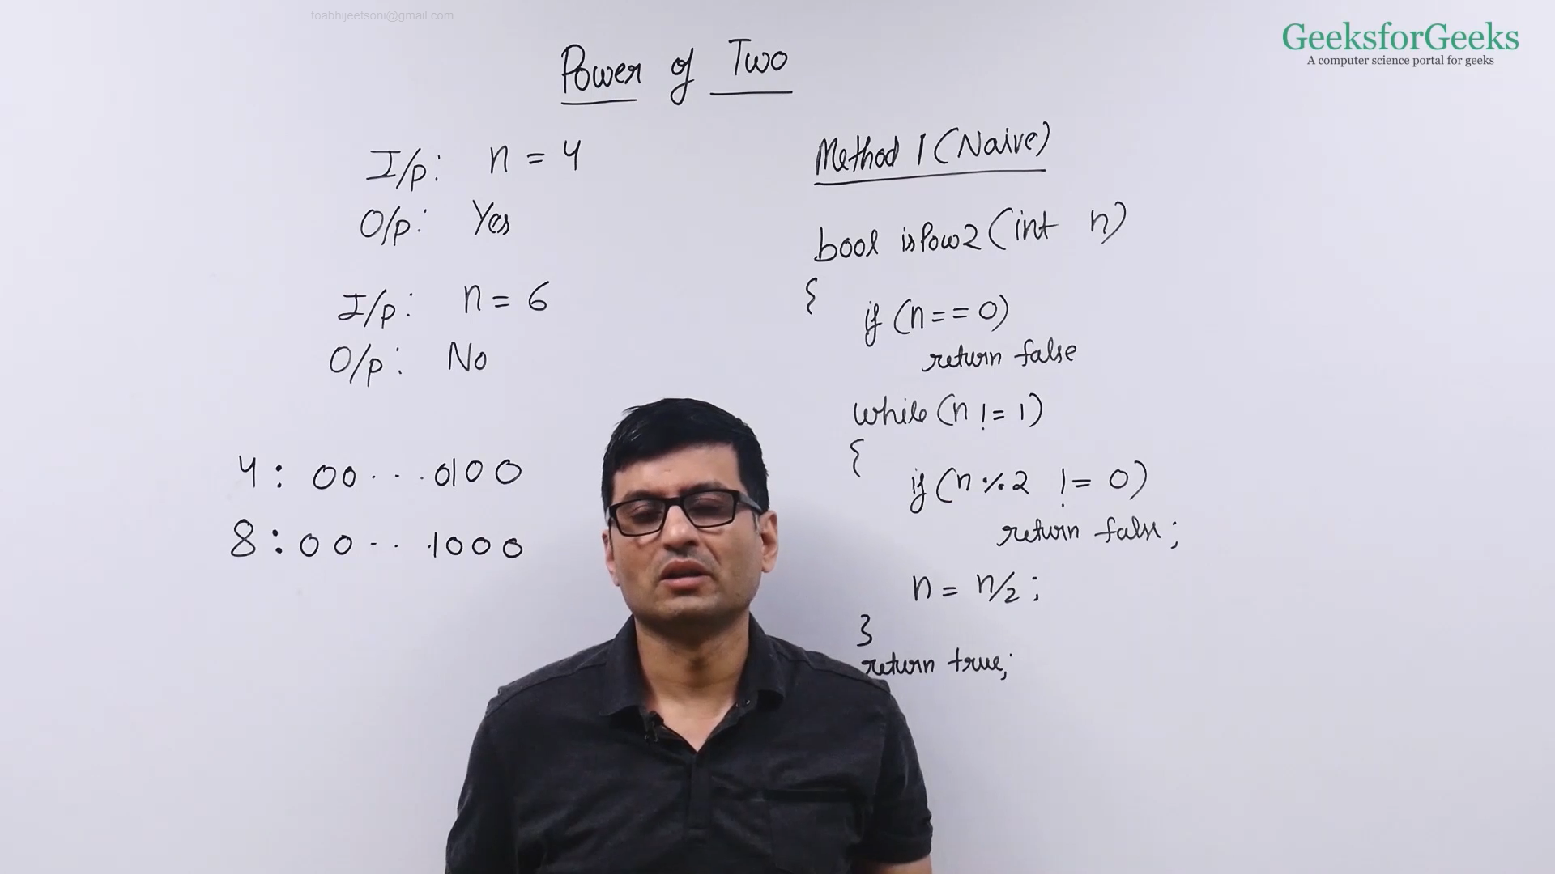

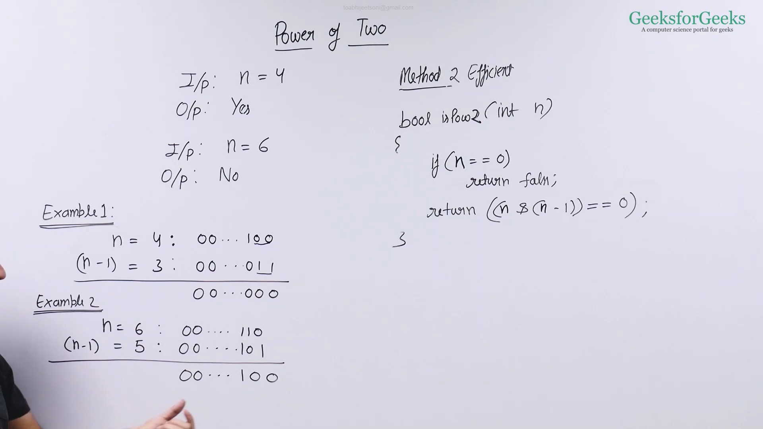

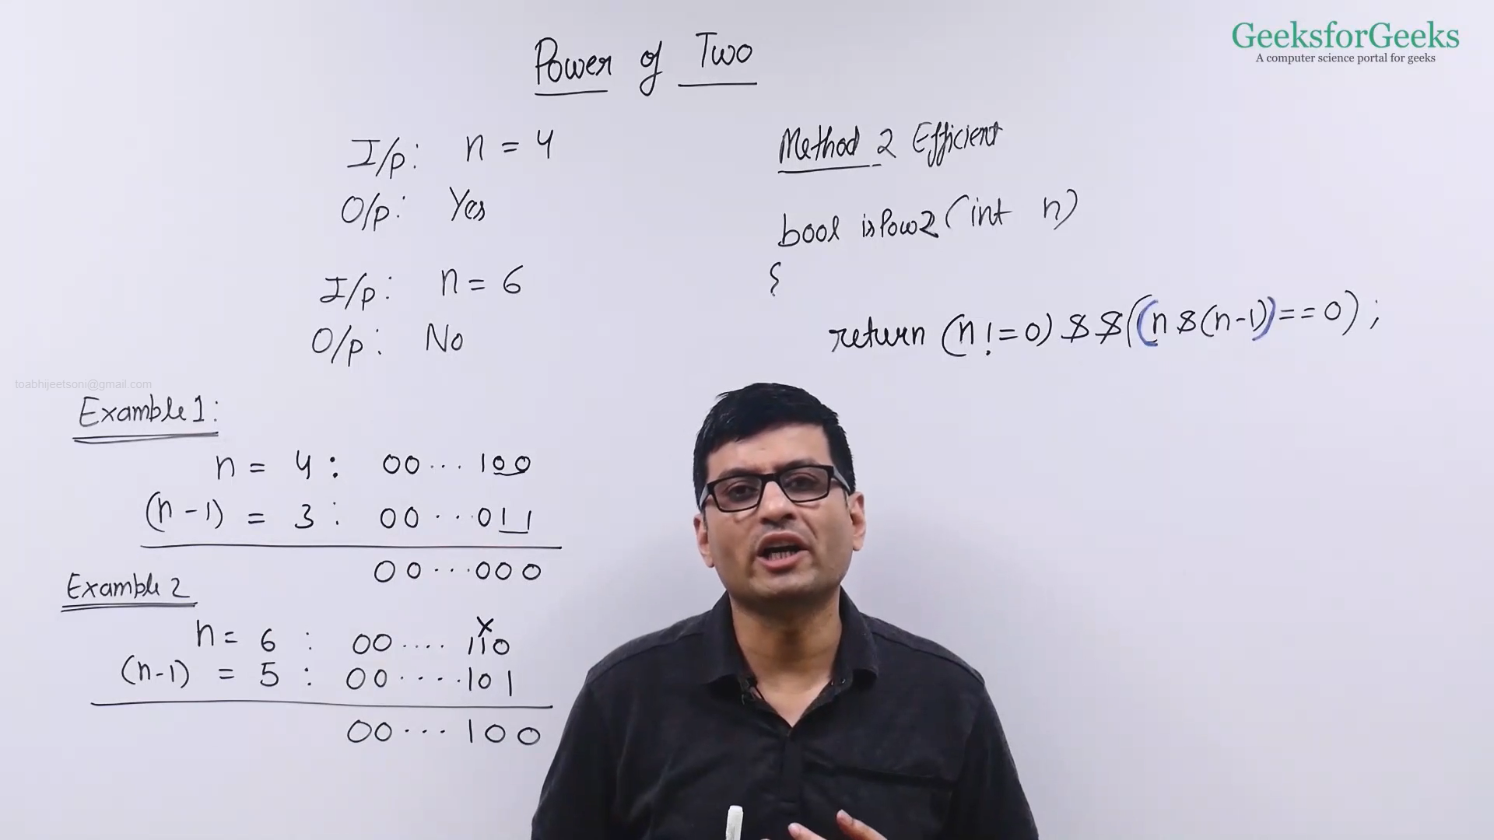

* Method 2(Efficient)
  + CPP:  <https://ide.geeksforgeeks.org/2HCmo9UEZb>
  + Java: <https://ide.geeksforgeeks.org/bQwFVbq7El>
* Method 1(Naive)
  + CPP: <https://ide.geeksforgeeks.org/dKNscCS3GZ>
  + Java: <https://ide.geeksforgeeks.org/R64Pms9NMd>

One Odd Occurring

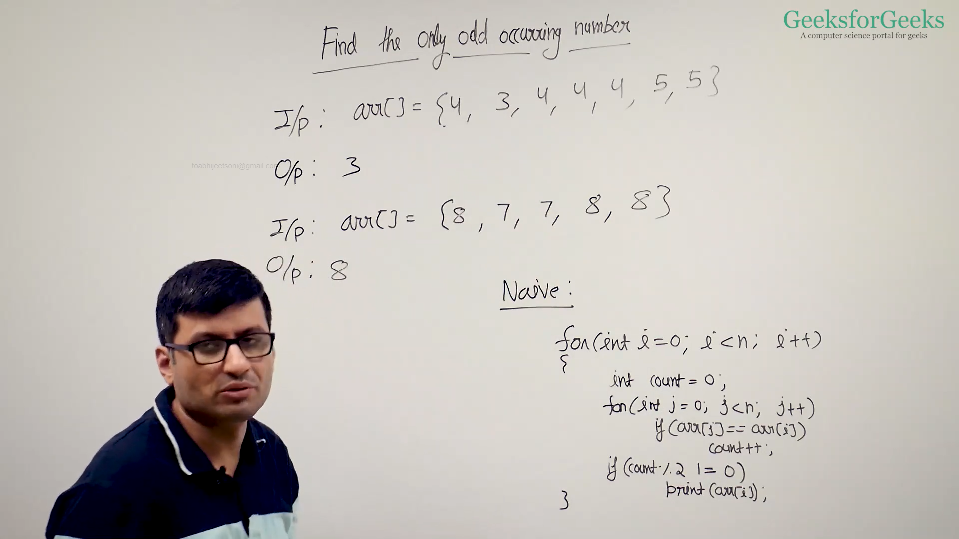

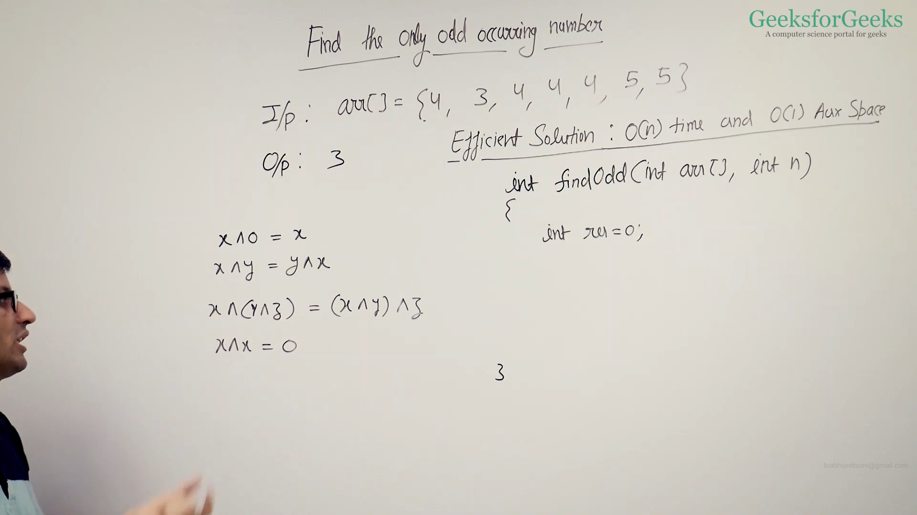

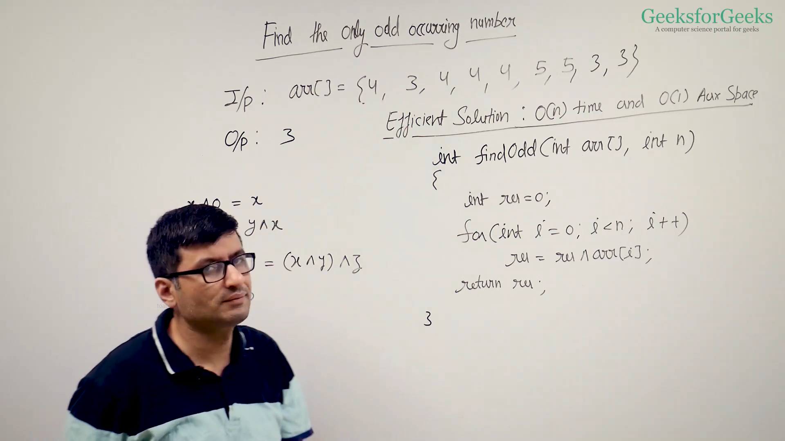

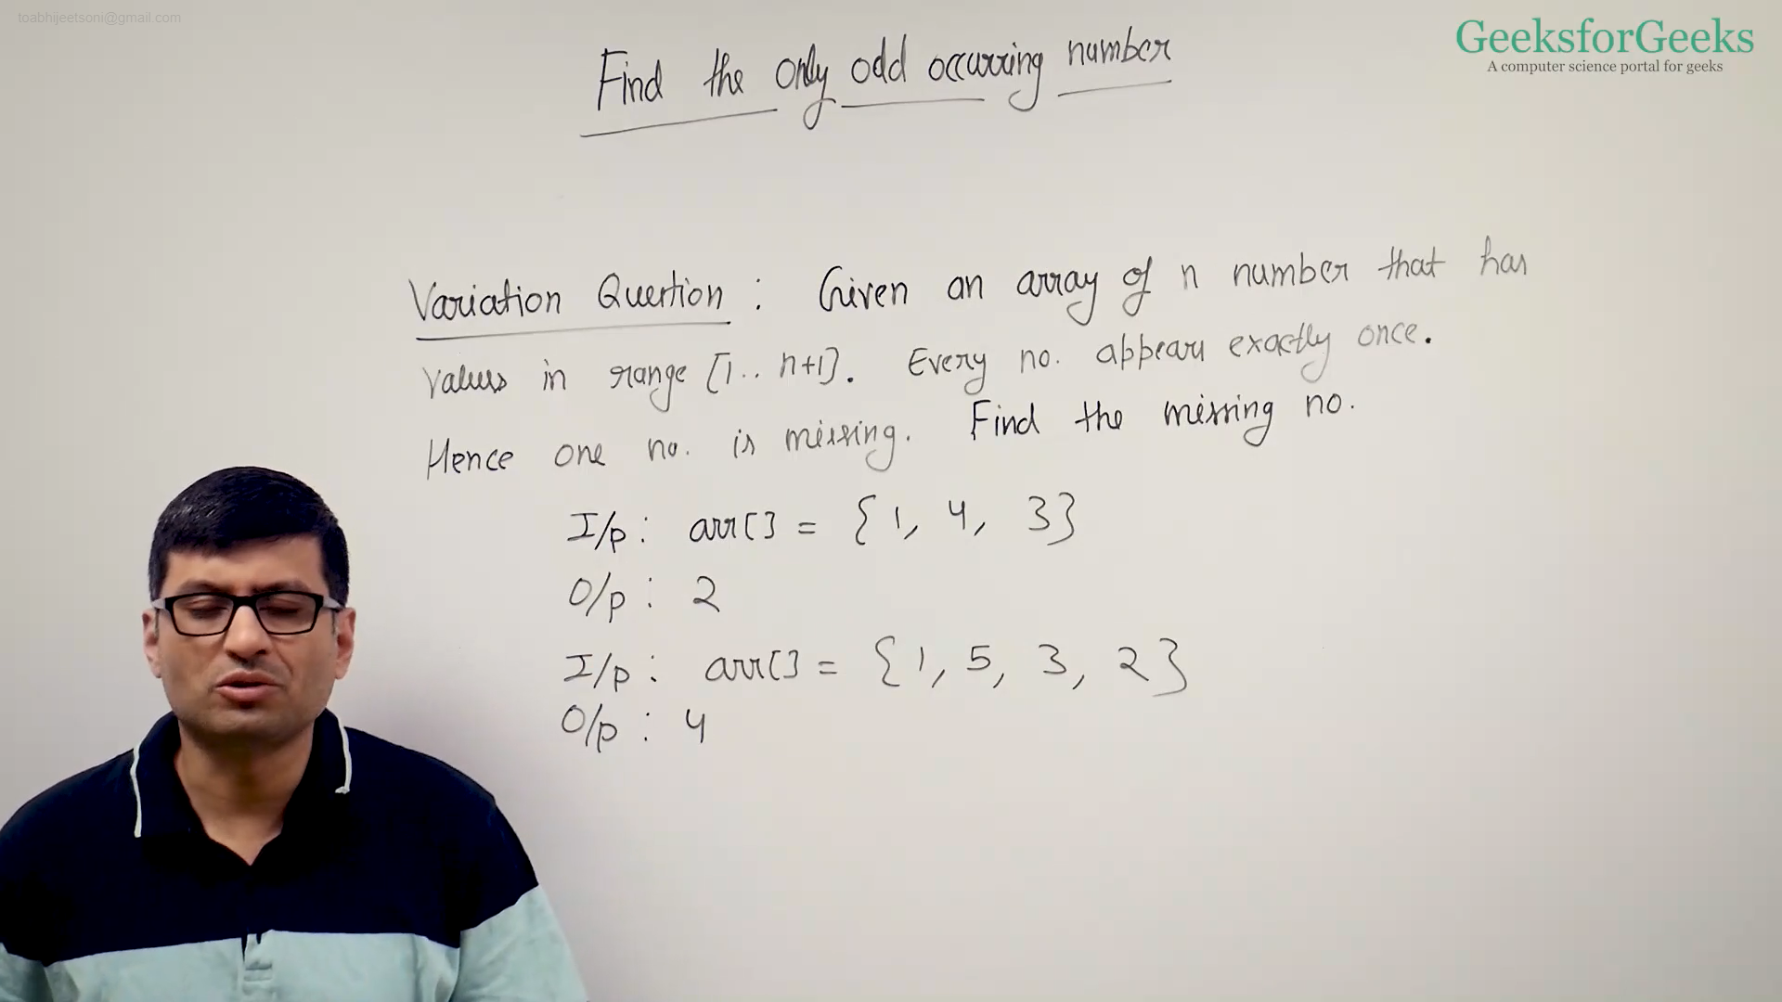

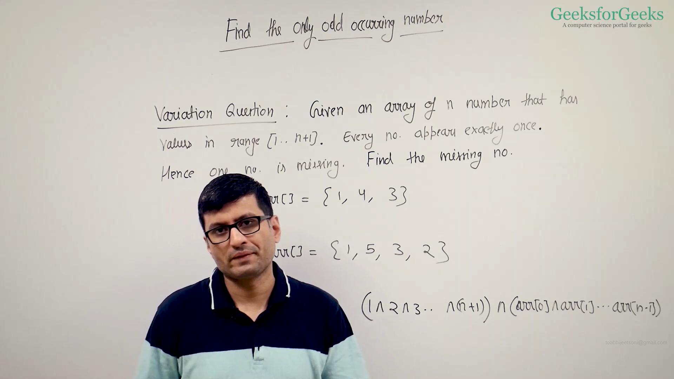

==========================================================

class MissingNo {

// Function to find missing number

static int getMissingNo(int a[], int n) {

int res_x1 = 0;

int res_x2 = 0;

/* For xor of all the elements in array */

for (int i = 0; i < n; i++) {

res_x1 = res_x1 ^ a[i];

}

/* For xor of all the elements from 1 to n+1 */

for (int i = 0; i <= n + 1; i++) {

res_x2 = res_x2 ^ i;

}

return (res_x1 ^ res_x2);

}

/* program to test above function */

public static void main(String args[]) {

int a[] = { 1, 2, 4, 5, 6, 7, 8, 9 };

int missingNo = getMissingNo(a, a.length);

System.out.println(missingNo);

}

}

==========================================================

* Naive Code
  + CPP: <https://ide.geeksforgeeks.org/zYzYy6ZWOj>
  + Java: <https://ide.geeksforgeeks.org/8wx6exrdQ9>
* Efficient Code
  + CPP: <https://ide.geeksforgeeks.org/1vlNsEAC49>
  + Java: <https://ide.geeksforgeeks.org/KL4TDwWnDd>

Two Odd Occurring

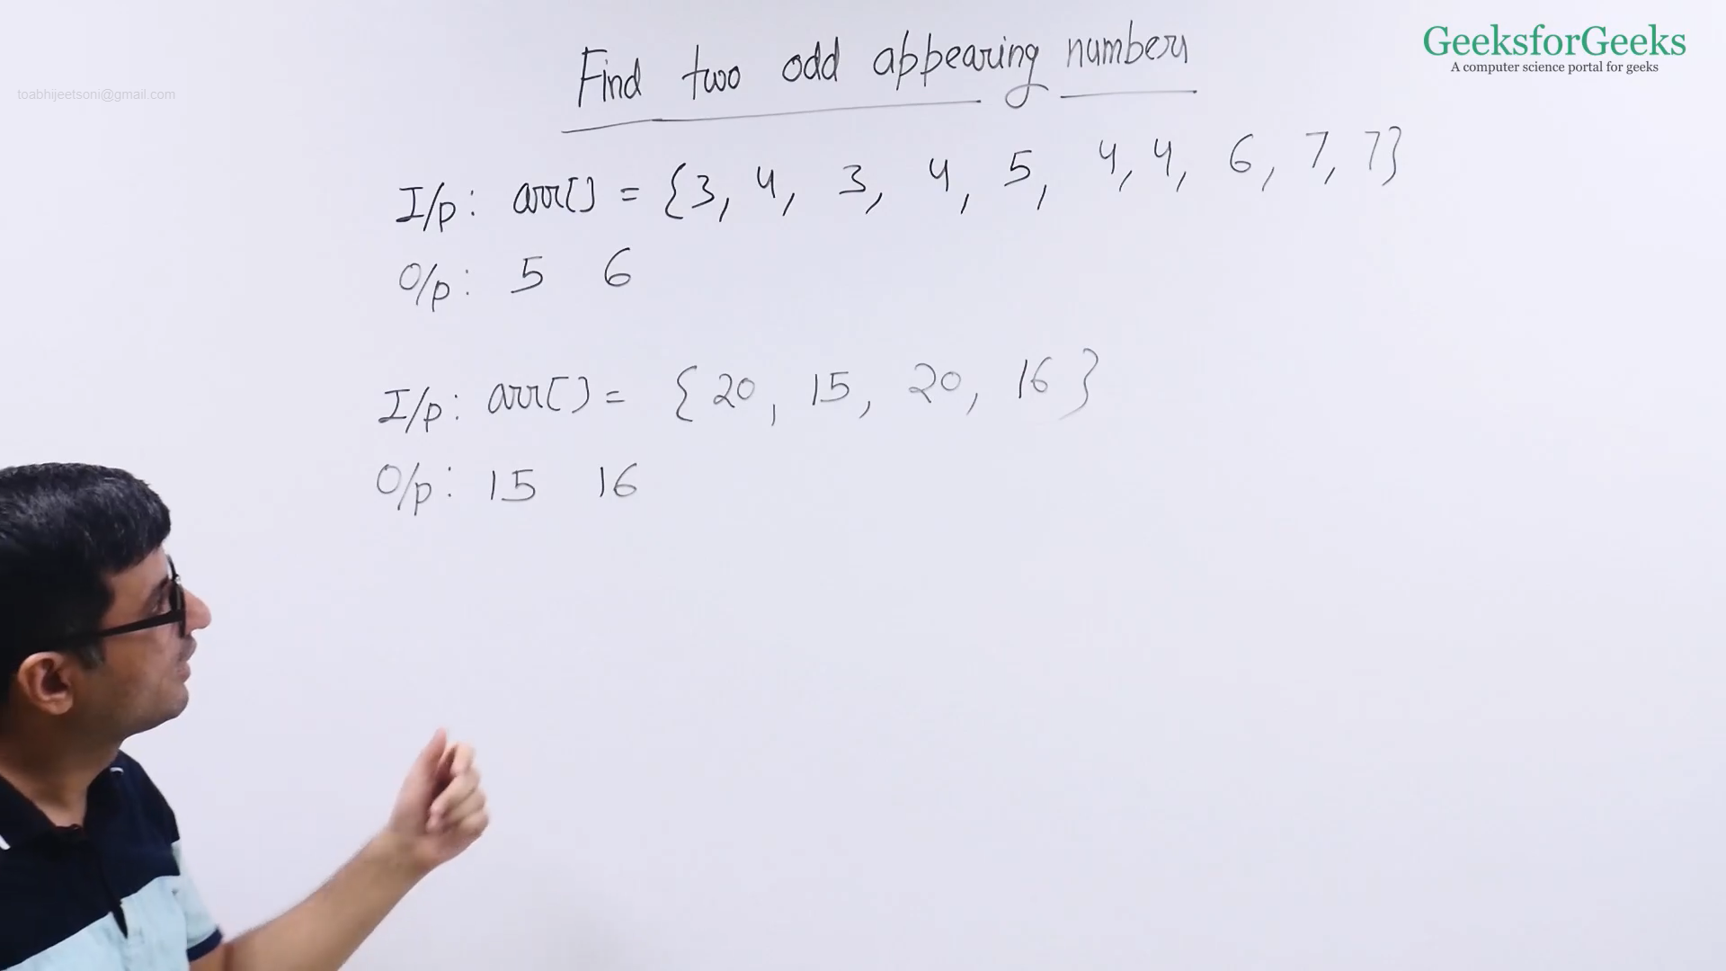

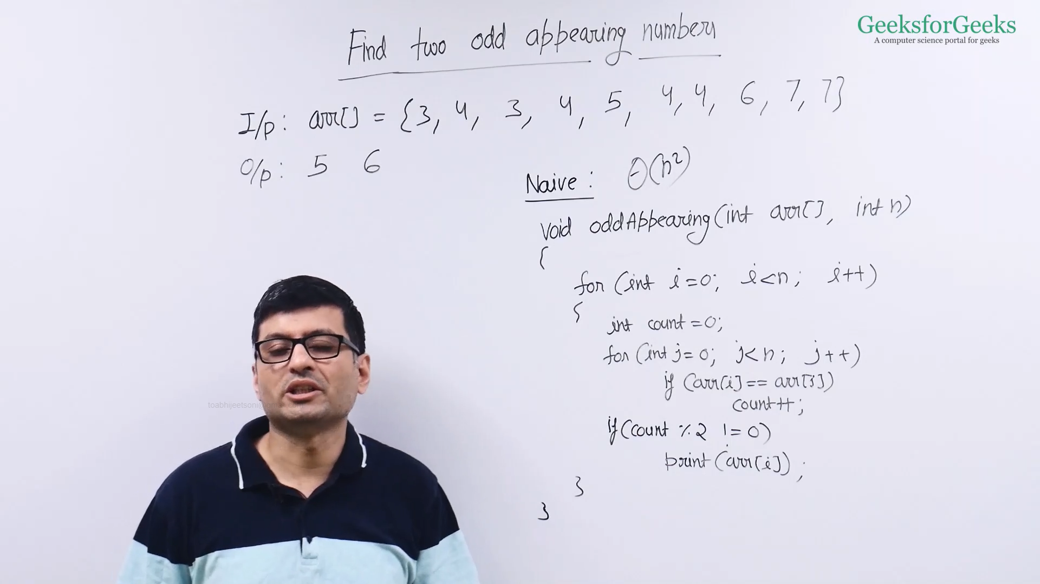

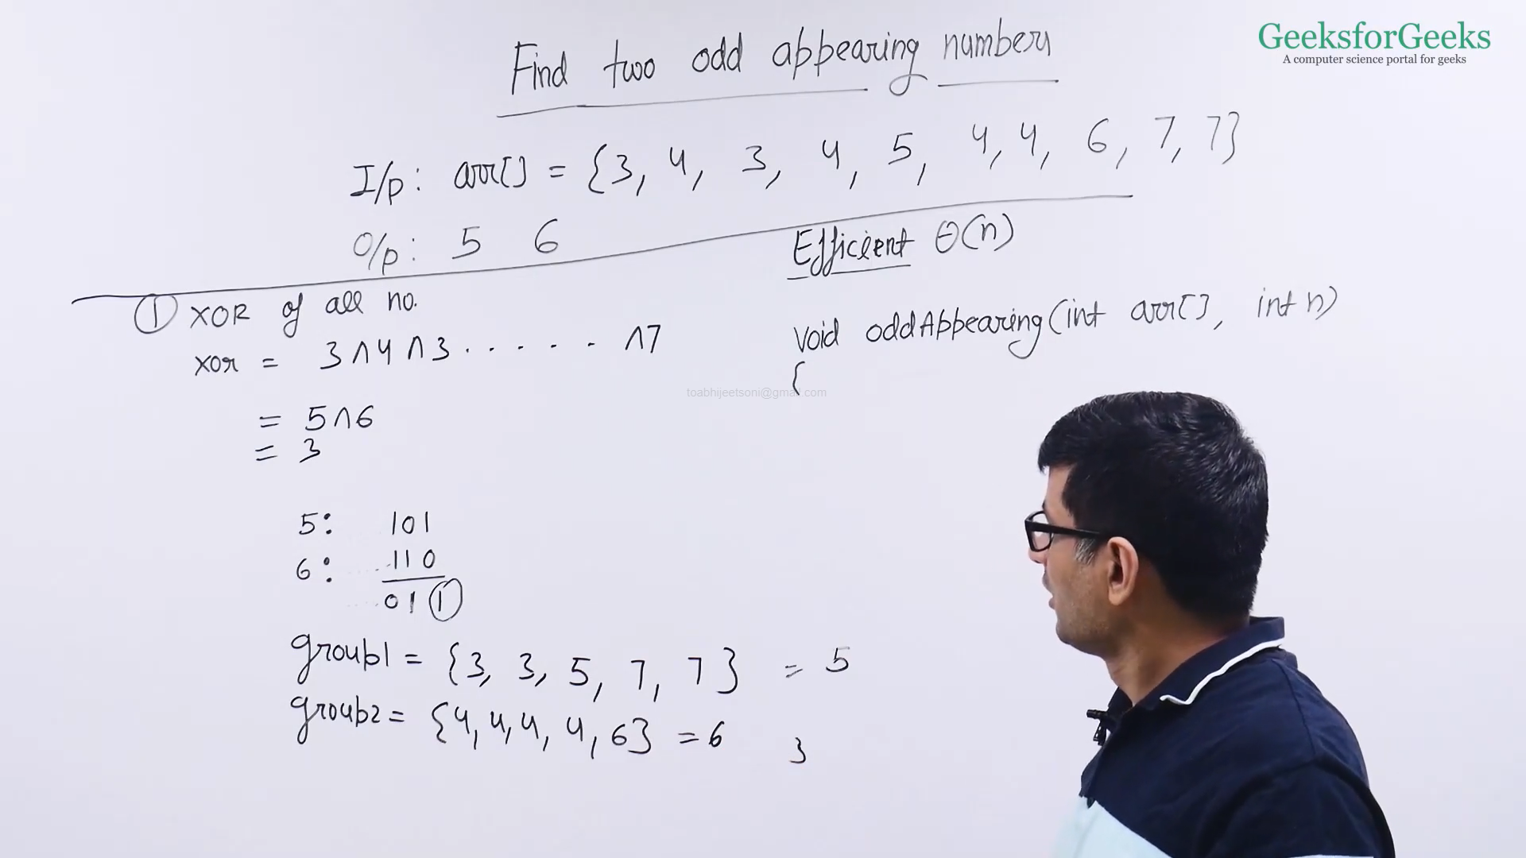

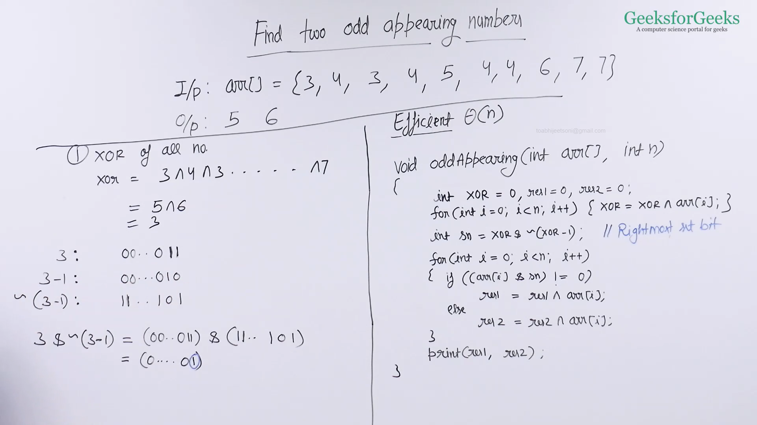

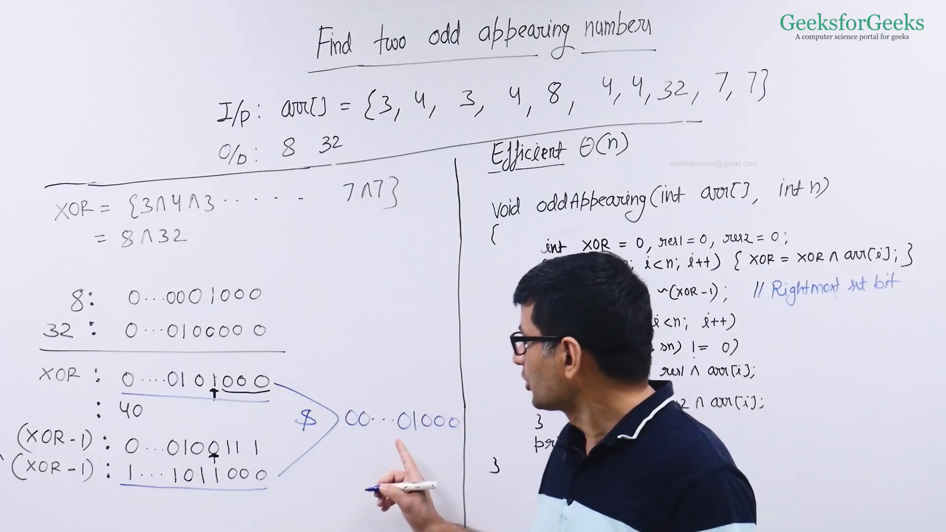

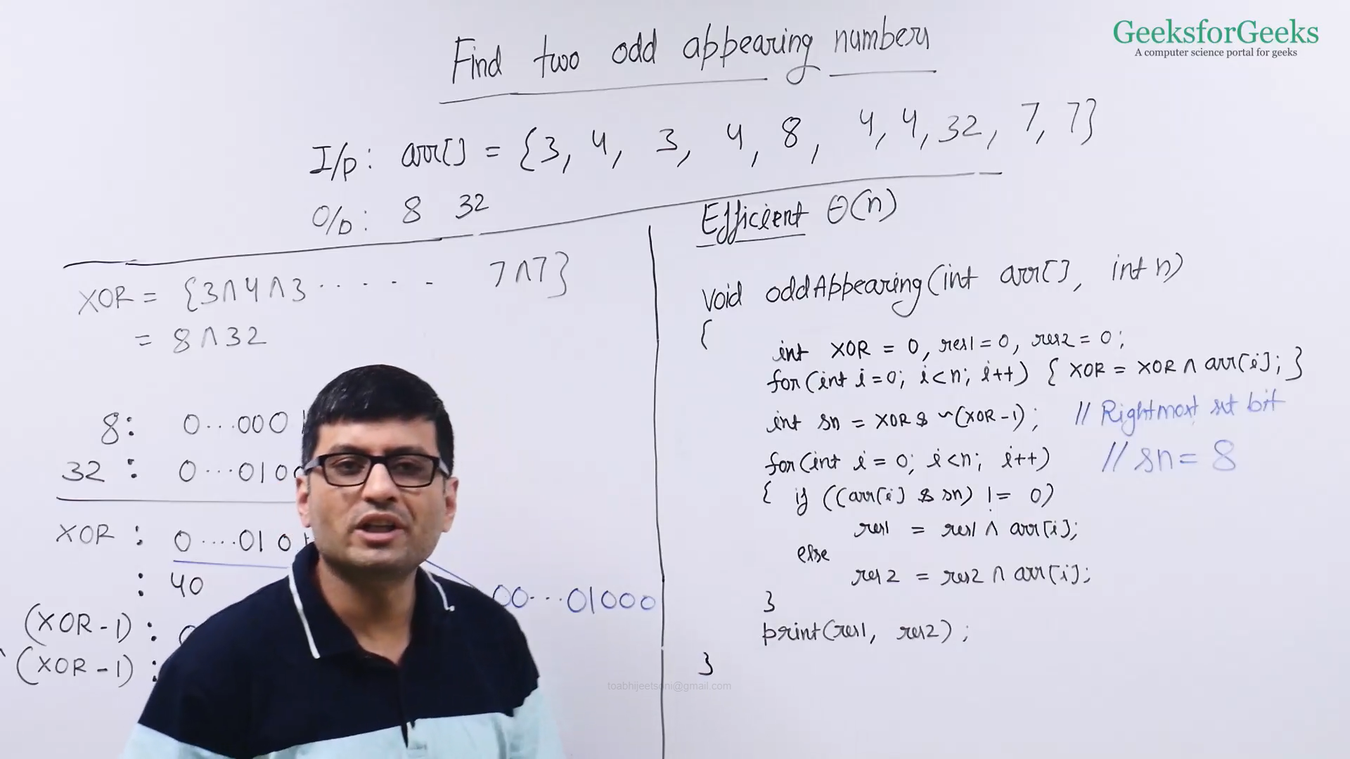

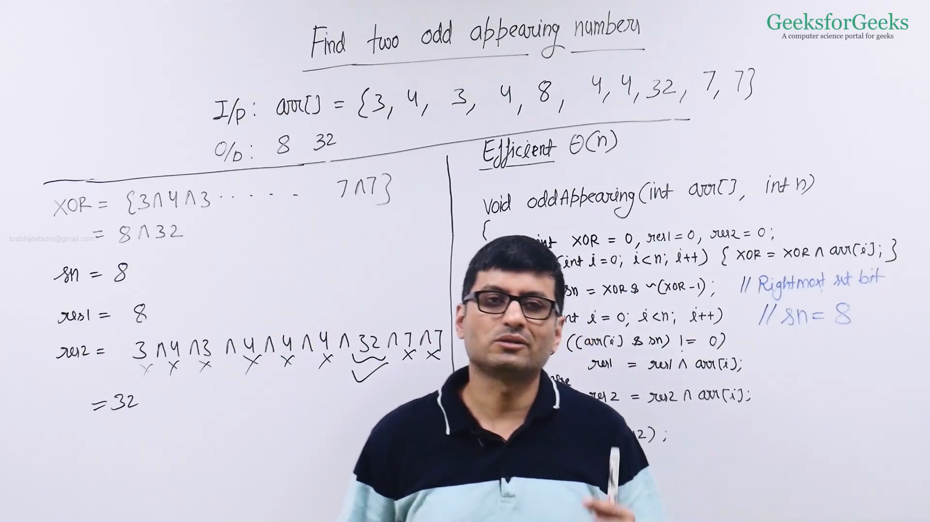

* Efficient Code
  + CPP: <https://ide.geeksforgeeks.org/lt06VhmUyL>
  + Java: <https://ide.geeksforgeeks.org/BOWIi1E89o>
* Naive Code
  + CPP: <https://ide.geeksforgeeks.org/1qBaw7xe0z>
  + Java: <https://ide.geeksforgeeks.org/TtNZCEU2A3>

Power Set using Bitwise

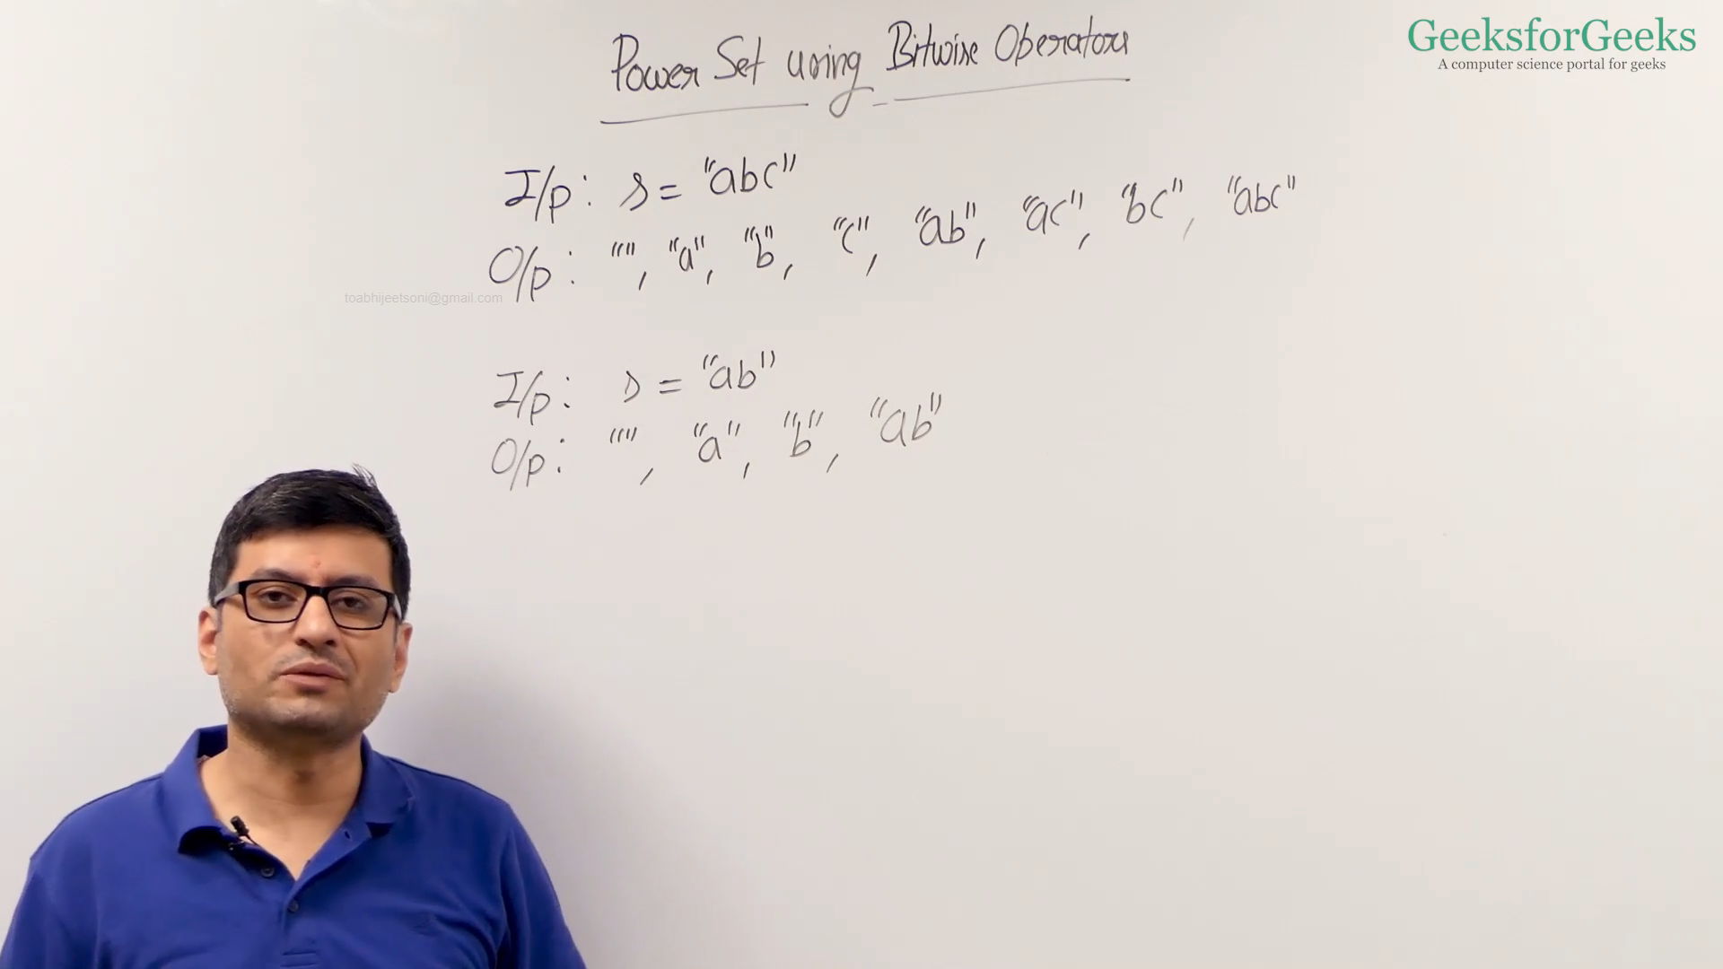

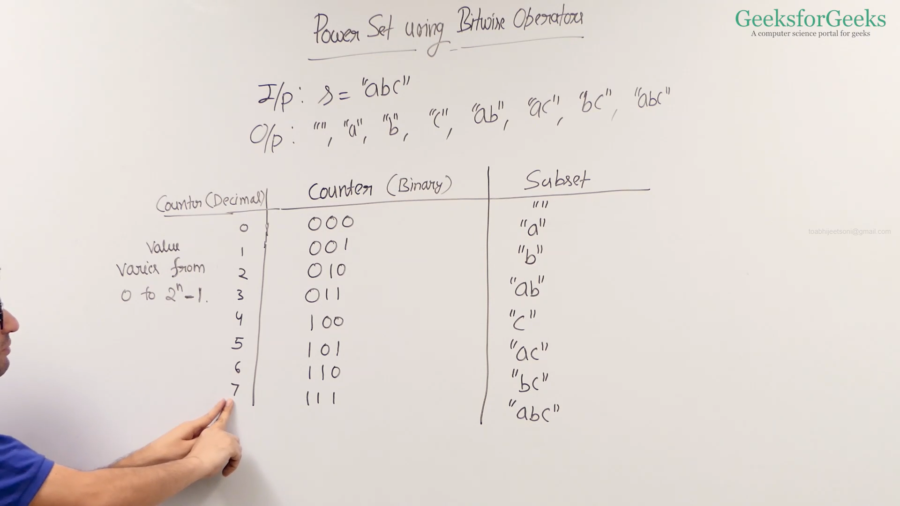

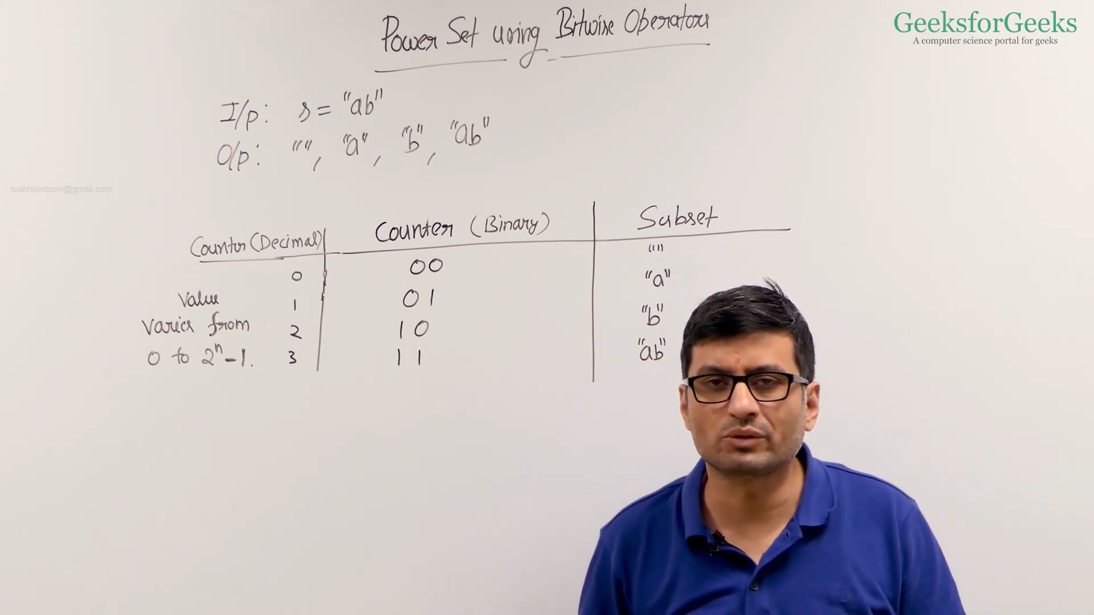

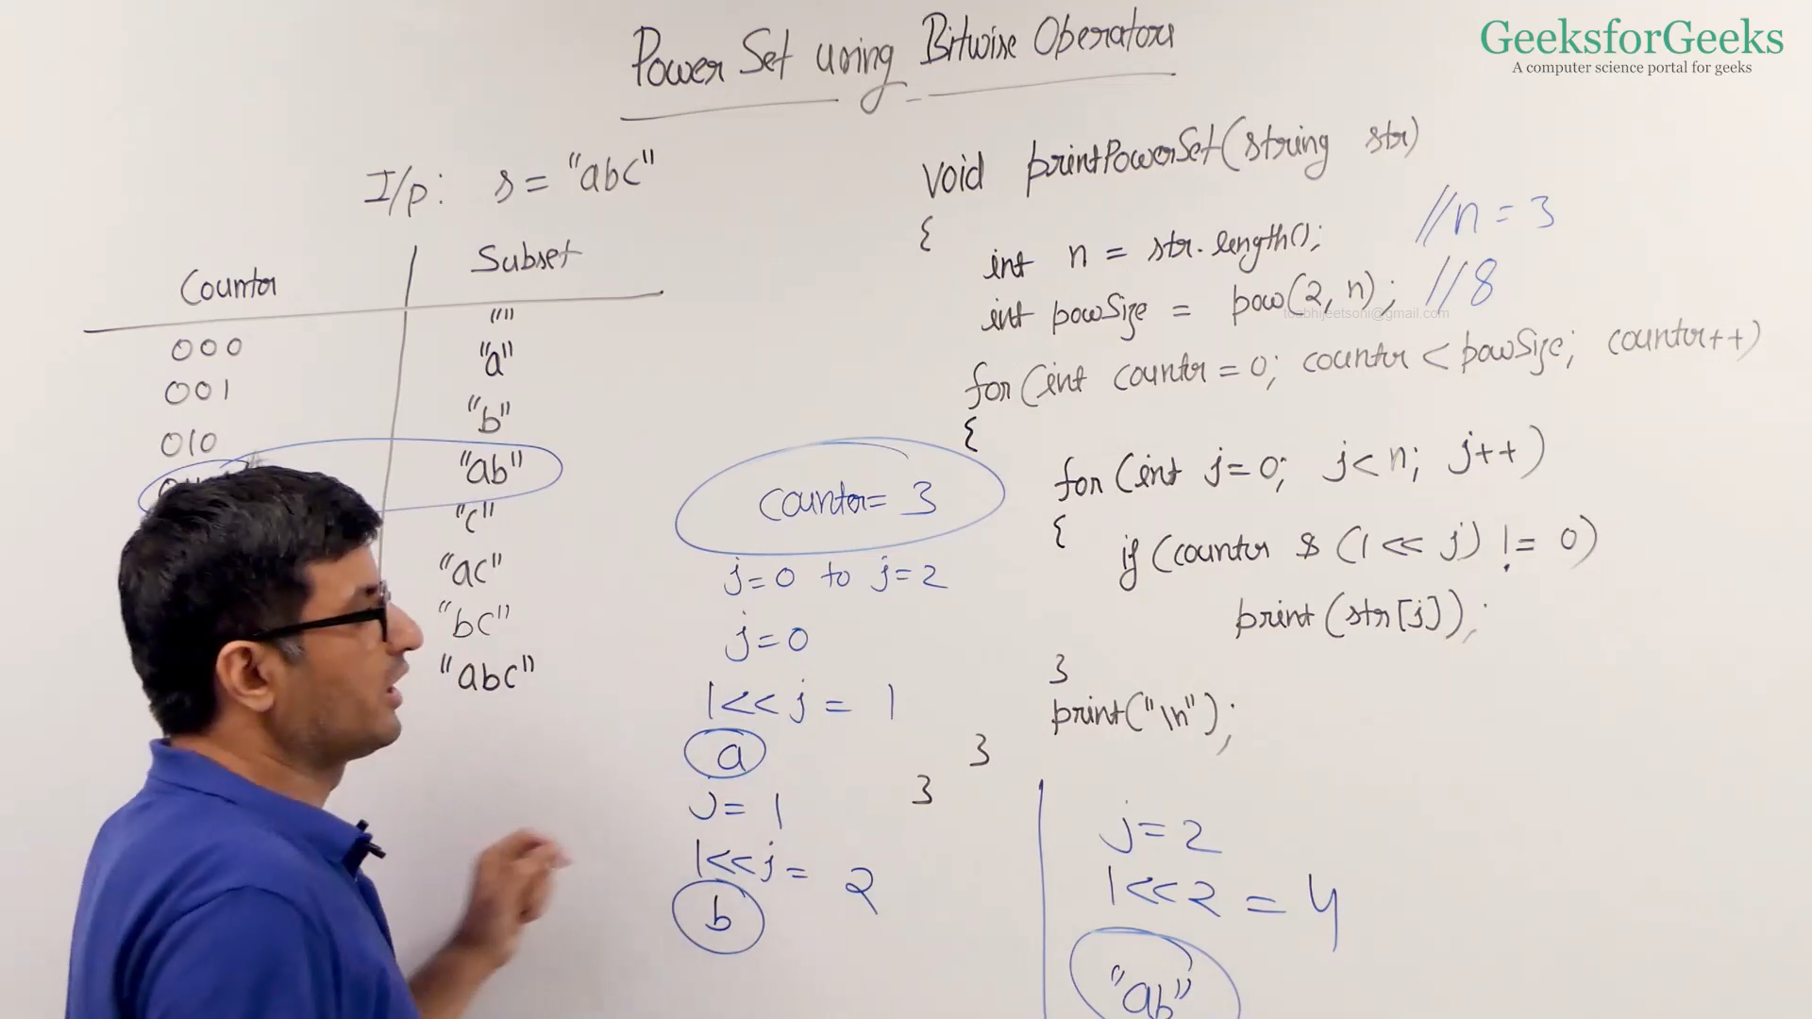

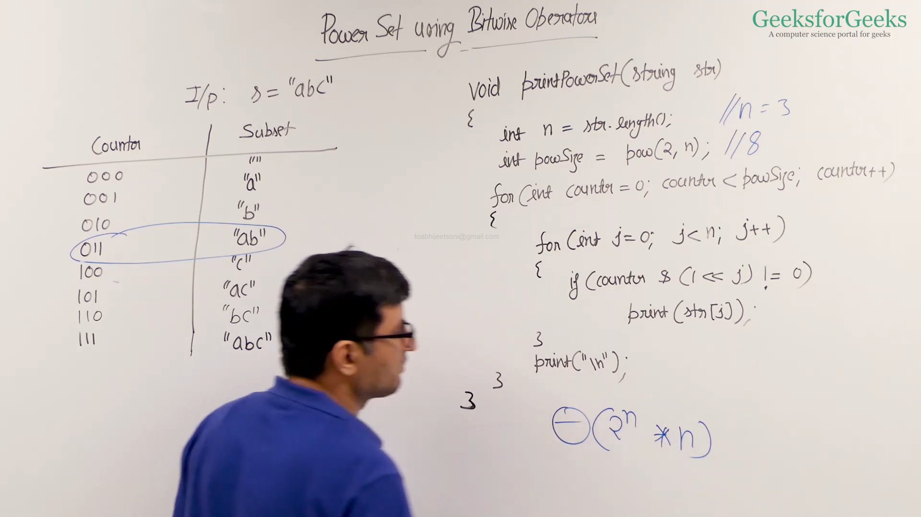

* CPP: <https://ide.geeksforgeeks.org/H3wPxim28h>
* Java: <https://ide.geeksforgeeks.org/HAMJewC5we>